Bike Rental Prediction

Vishal Maurya

23 September 2019

Contents

# 1 Introduction

1.1 Problem Statement . . . . . . . . . . . . . . . . . . . . . . . . . . . . . . . . . . . . . . . . . . . . . . . . . . . . . . . . . . . . . . . . . . . . . . .3

1.2 Data . . . . . . . . . . . . . . . . . . . . . . . . . . . . . . . . . . . . . . . . . . . . . . . . . . . . . . . . . . . . . . . . . . . . . . . . . . . . . . . . . . . . 3

# 2 Methodology

2.1 Exploratory Data Analysis . . . . . . . . . . . . . . . . . . . . . . . . . . . . . . . . . . . . . . . . . . . . . . . . . . . . . . . . . . . . . . . 6

2.1.1 Descriptive Analysis . . . . . . . . . . . . . . . . . . . . . . . . . . . . . . . . . . . . . . . . . . . . . . . . . . . . . . . . . . . 6

2.1.1.1 Features Analysis . . . . . . . . . . . . . . . . . . . . . . . . . . . . . . . . . . . . . . . . . . . . . . . . . . . . . .6

2.1.1.1 Missing Value Analysis . . . . . . . . . . . . . . . . . . . . . . . . . . . . . . . . . . . . . . . . . . . . . . . . .7

2.1.1.3 Target Variable Analysis . . . . . . . . . . . . . . . . . . . . . . . . . . . . . . . . . . . . . . . . . . . . . . .7

2.1.2 Visualization . . . . . . . . . . . . . . . . . . . . . . . . . . . . . . . . . . . . . . . . . . . . . . . . . . . . . . . . . . . . . . . . . . .8

2.1.2.1 Attributes Distributions and trends . . . . . . . . . . . . . . . . . . . . . . . . . . . . . . . . . . .8

2.1.2.2 Outlier Analysis . . . . . . . . . . . . . . . . . . . . . . . . . . . . . . . . . . . . . . . . . . . . . . . . . . . . . .16

2.2 Data Preprocessing and Analysis . . . . . . . . . . . . . . . . . . . . . . . . . . . . . . . . . . . . . . . . . . . . . . . . . . . . . . . . 18

2.2.1 Outlier Handling . . . . . . . . . . . . . . . . . . . . . . . . . . . . . . . . . . . . . . . . . . . . . . . . . . . . . . . . . . . . . . .18

2.2.2 Feature Selection . . . . . . . . . . . . . . . . . . . . . . . . . . . . . . . . . . . . . . . . . . . . . . . . . . . . . . . . . . . . . 18

2.2.3 Feature Engineering . . . . . . . . . . . . . . . . . . . . . . . . . . . . . . . . . . . . . . . . . . . . . . . . . . . . . . . . . . . .19

2.3 Modeling . . . . . . . . . . . . . . . . . . . . . . . . . . . . . . . . . . . . . . . . . . . . . . . . . . . . . . . . . . . . . . . . . . . . . . . . . . . . . . . .21

2.3.1 Model Selection . . . . . . . . . . . . . . . . . . . . . . . . . . . . . . . . . . . . . . . . . . . . . . . . . . . . . . . . . . . . . . . 21

2.3.2 Multilinear & Regularization Regression . . . . . . . . . . . . . . . . . . . . . . . . . . . . . . . . . . . . . . .21

2.3.3 Random Forest . . . . . . . . . . . . . . . . . . . . . . . . . . . . . . . . . . . . . . . . . . . . . . . . . . . . . . . . . . . . . . . . . .25

2.3.4 Gradient Boosting . . . . . . . . . . . . . . . . . . . . . . . . . . . . . . . . . . . . . . . . . . . . . . . . . . . . . . . . . . . . . .27

# 3 Conclusion

3.1 Model Evaluation . . . . . . . . . . . . . . . . . . . . . . . . . . . . . . . . . . . . . . . . . . . . . . . . . . . . . . . . . . . . . . . . . . . . . . . .29

3.1.1 R-squared & Adj R-squared Value . . . . . . . . . . . . . . . . . . . . . . . . . . . . . . . . . . . . . . . . . . . . . . . . . . . . . .33

3.1.2 Root Mean Squared Error & Root Mean Squared Log Error. . . . . . . . . . . . . . . . . . . . . . . . . . . . . . . .33

3.2 Model Selection . . . . . . . . . . . . . . . . . . . . . . . . . . . . . . . . . . . . . . . . . . . . . . . . . . ... . . . . . . . . . . . . . . . . . . . 34

# Appendix A - Extra Figures

# Appendix B – Complete Python and R Code

Python Code . . . . . . . . . . . . . . . . . . . . . . . . . . . . . . . . . . . . . . . . . . . . . . . . . . . . . . . . . . . . . . . . . . . . . . . . . . . . . . . . 45

R Code . . . . . . . . . . . . . . . . . . . . . . . . . . . . . . . . . . . . . . . . . . . . . . . . . . ... . . . . . . . . . . . . . . . . . . . . . . . . . . . . . . . .66

# References

# Chapter 1

Introduction

# 1.1 Problem Statement

The usage of bicycles as a mode of transportation has gained traction in recent years due to with environmental and health issues. The cities across the world have successfully rolled out bike sharing programs to encourage usage of bikes. Under such programs, the riders can rent bicycles using manual or automated stalls spread across the city for defined periods. In most cases, riders can pick up bikes from one location and returned them any other designated place. The bike sharing programs from across the world are hotspots of all sorts of data, ranging from travel time, start and end location, demographics of riders, and so on. This data along with alternate sources of information such as weather, traffic, terrain, season and so on.

**The objective of this Case is to Predication of bike rental count on daily based on the environmental and seasonal settings.**

The objective is to forecast bike rental demand of Bike sharing program in Washington, D.C based on historical usage patterns in relation with weather, environment and other data. We would be interested in predicting the rentals on various factors including season, temperature, weather and building a model that can successfully predict the number of rentals on relevant factors.

# 1.2 Data

This dataset contains the seasonal and weekly count of rental bikes between years 2011 and 2012 in Capital bikeshare system with the corresponding temperature and humidity information. Bike sharing systems are a new way of traditional bike rentals. The whole process from membership to rental and return back has become automatic. The data was generated by 500 bike-sharing programs and was collected by the Laboratory of Artiﬁcial Intelligence and Decision Support (LIAAD), University of Porto. Given below is the description of the data which is a (731, 16) shaped data.

Short description of features

1. instant: Record index
2. dteday: Date
3. season: Season (1:spring, 2:summer, 3:fall, 4:winter)
4. yr: Year (0: 2011, 1:2012)
5. mnth: Month (1 to 12)
6. holiday: weather day is holiday or not (extracted from Holiday Schedule)
7. weekday: Day of the week
8. workingday: If day is neither weekend nor holiday it's 1, otherwise is 0.
9. weathersit: (extracted from Freemeteo)
   1. Clear, Few clouds, Partly cloudy, Partly cloudy
   2. Mist + Cloudy, Mist + Broken clouds, Mist + Few clouds, Mist
   3. Snow, Light Rain + Thunderstorm + Scattered clouds, Light Rain + Scattered clouds
   4. Heavy Rain + Ice Pallets + Thunderstorm + Mist, Snow + Fog
10. temp: Normalized temperature in Celsius.
11. atemp: Normalized feeling temperature in Celsius.
12. hum: Normalized humidity. The values are divided to 100 (max)
13. windspeed: Normalized wind speed. The values are divided to 67 (max)
14. casual: count of casual users
15. registered: count of registered users
16. cnt: count of total rental bikes including both casual and registered

In this project, our task is to build regression models which will used to predict the bike rental count on daily basis. Given below is a sample of the bike sharing dataset:

**Fig 1.1: Bike sharing Dataset**

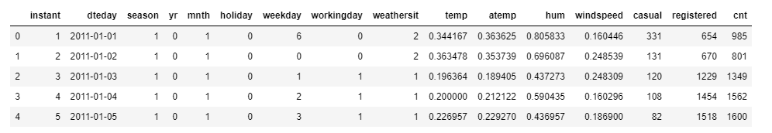

As you can see in the table below, we have the following 12 variables, using which we must correctly predict the bike rental count, column name has been renamed:

**Fig 1.2: Predictor Variables** 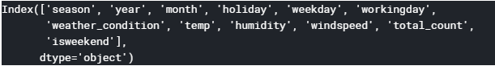

We have created a new feature:

* isweekend – extracted weekend days from datetime feature.

We have dropped the following variables from our dataset:

1. Instant- it represents the index of a record
2. dteday – it represents date on the given day
3. atemp - Normalized feeling temperature strongly correlated with temp
4. Casual and Registered- they are leakage variables in nature (dependent) and need to drop during model building to avoid bias. (casual + registered = count)

# Chapter 2

Methodology

# 2.1 Exploratory Data Analysis (EDA)

Exploratory data analysis (EDA) is a very important step which takes place after feature engineering and acquiring data and it should be done before any modeling. This is because it is very important for a data scientist to be able to understand the nature of the data without making assumptions. The results of data exploration can be extremely useful in grasping the structure of the data, the distribution of the values, and the presence of extreme values and interrelationships within the data set. It involves the loading dataset, target classes count, data cleaning, typecasting of attributes, missing value analysis, Attributes distributions and trends.

**> Purpose of EDA:**

1. Summarize the statistics and visualization of data for better understanding. Curbing indication for tendencies of the data, its quality and to formulate assumptions and the hypothesis of our analysis.

2. To create an overall picture of the data with basic statistical description and aspects, and identify

# 2.1.1 Descriptive Analysis

It is a summary statistic that quantitatively describes or summarizes features of a collection of information, process of condensing key characteristics of the data set into simple numeric metrics. Some of the common metrics used are mean, standard deviation, and correlation.

## 2.1.1.1 Feature Analysis

Generating profile report using pandas_profiling

For each column the following statistics are presented in an interactive HTML page:

* Essentials: type, unique values, missing values

* Quantile statistics: minimum value, Q1, median, Q3, maximum, range, interquartile range

* Descriptive statistics: mean, mode, standard deviation, sum, median absolute deviation, coefficient of variation, kurtosis, skewness

Most frequent values

* Histogram

* Correlations highlighting of highly correlated variables, Spearman and Pearson matrixes

**Fig 2.1: Panda Profiling**

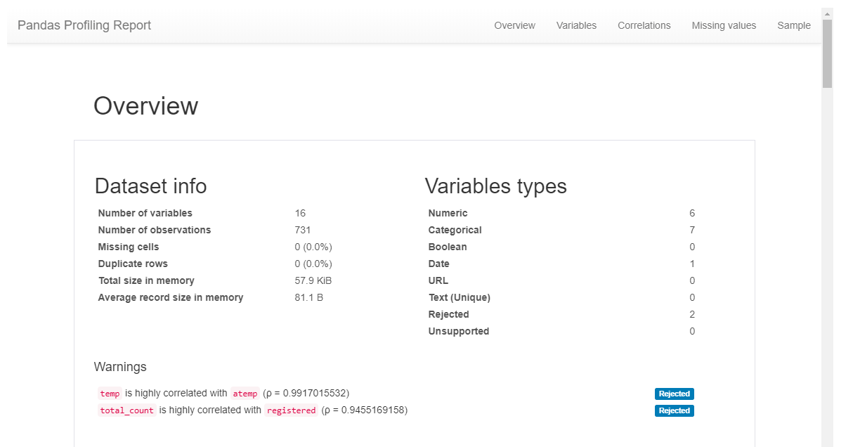

Fig 2.2: Train information

# 

## 2.1.1.2 Missing value analysis

In this, we need to find out any missing values are present in dataset. We have not found any missing values in both train and test data.

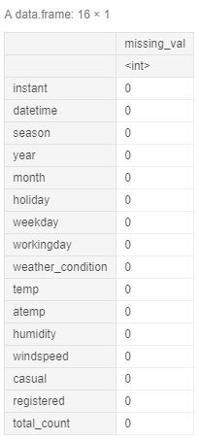Python and R code as follows:

1. Python

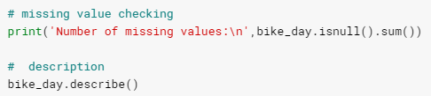

1. R

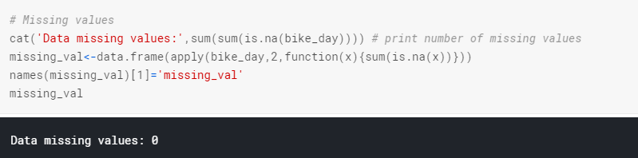

## 2.1.1.3 Target Value

Target variable (total count) distribution

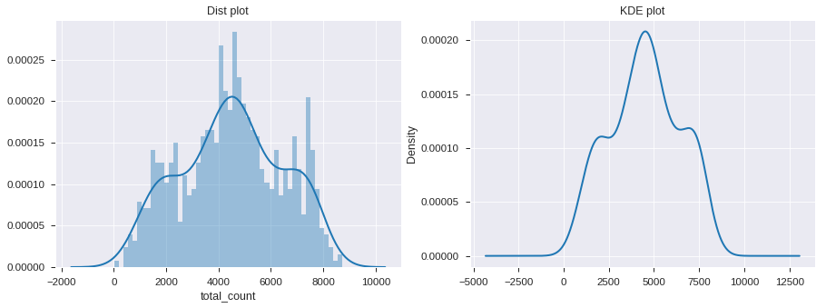

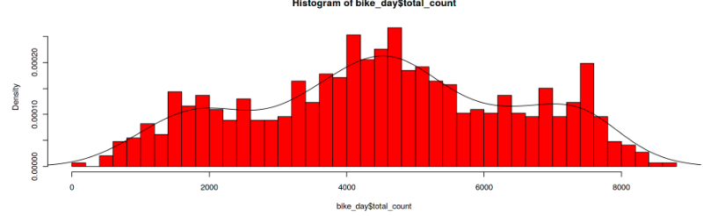

# 2.1.2 Visualization

It is the process of projecting the data, or parts of it, into Cartesian space or into abstract images. With a little domain knowledge, data visualizations can be used to express and demonstrate key relationships in plots and charts that are more visceral to yourself and stakeholders than measures of association or significance. In the data mining process, data exploration is leveraged in many different steps including preprocessing, modeling, and interpretation of results.

One of our main goals for visualizing the data here, is to observe which features are most intuitive in predicting target. The other, is to draw general trend, may aid us in model selection and hyper parameter selection.

## 2.1.2.1 Attribute Distribution and Trends

### Categorical Features

### 

**Key Findings**:

1. People like to rent bikes more whenever the sky is clear.
2. the count of number of rented bikes is maximum in fall (Autumn) season and least in spring season.
3. number of bikes rented per season over the years has increased for both casual and registered users.
4. registered users have rented more bikes than casual users overall.
5. casual users travel more over weekends as compared to registered users (Saturday / Sunday).
6. registered users rent more bikes during working days as expected for commute to work / office.
7. demand for bikes are more on working days as compared to holidays (because majority of the bike users are registered)

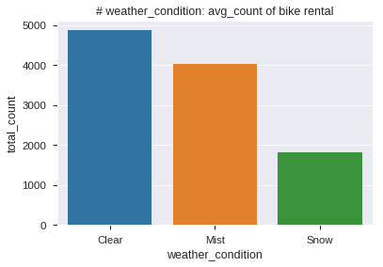 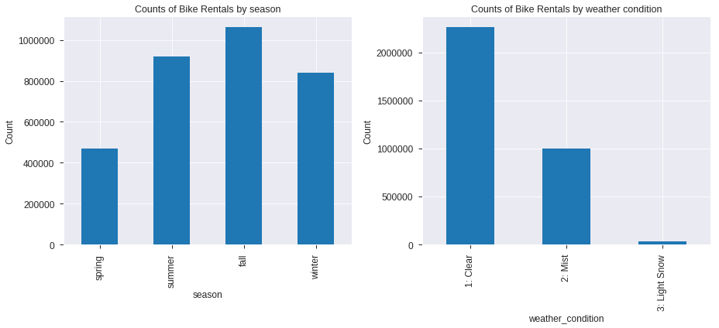

**Observation:**

1. People like to rent bikes more whenever the sky is clear.
2. the count of number of rented bikes is maximum in fall (Autumn) season and least in spring season.

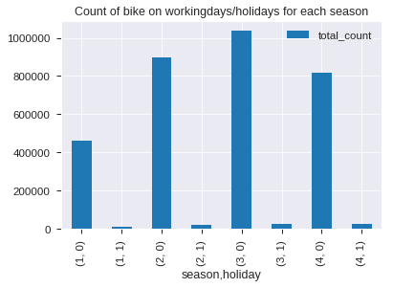

**Observation:**

1. For all season, number of workdays rental is much higher than holidays.
2. Both workday and holiday is following same trend over the seasonal rental count and being highest in fall.

**Observation:**

1. Total, casual, registered rental count increased by next year.
2. All are following same trend over the seasonal rental count and being highest in fall.
3. Casual rental count is lesser than the registered rental counts.

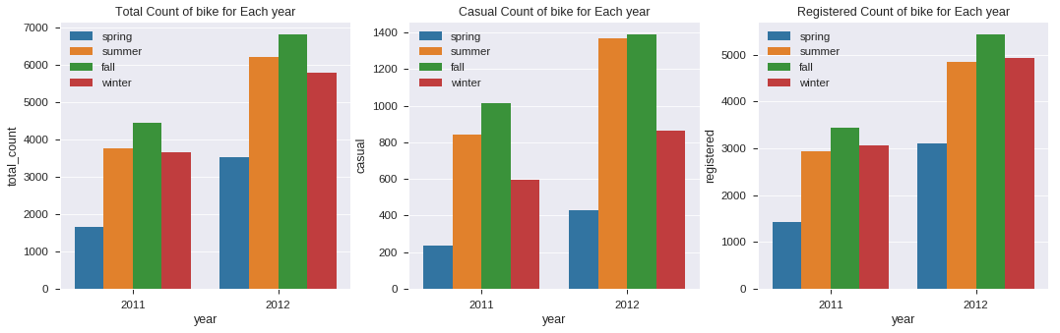

**Observation:**

1. For each season, people prefer clear weather for renting bike.
2. All are following same trend over the seasonal rental count and being highest in fall on clear weather days.

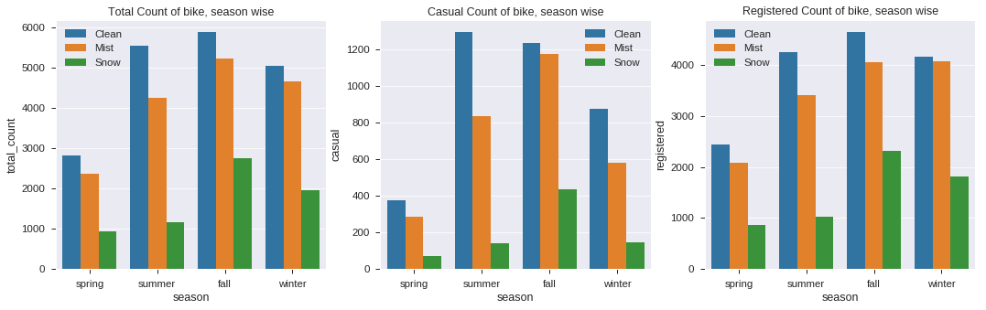

**Observation:**

1. Count of bike rental on Friday, Saturday & Sunday is always higher than Mondays.

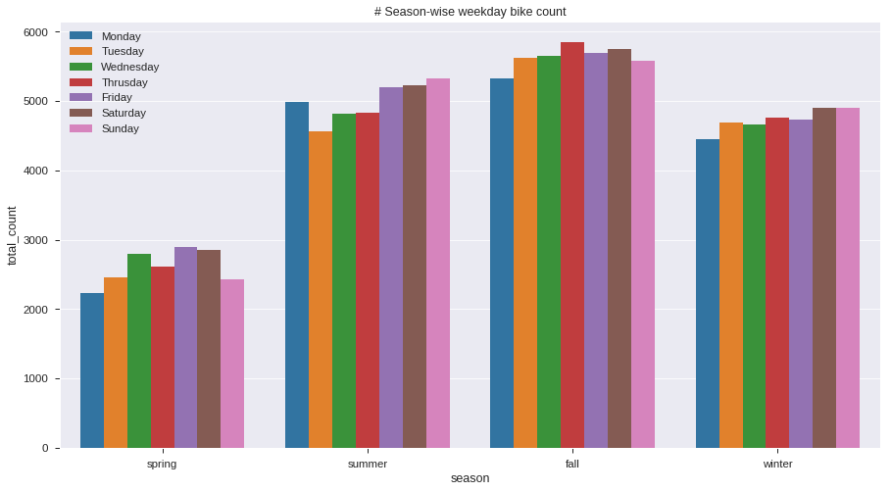

**Observation**:

1. Between May (5) to October (10) renting is high for all over the week.
2. Monday being the most fluctuating trend.

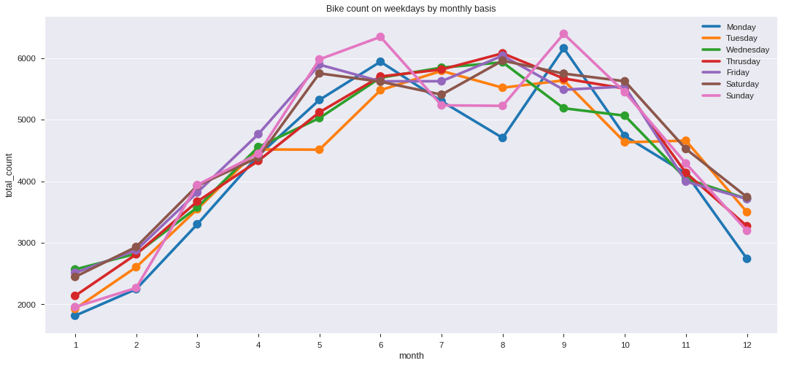

**Observation**:

* Overall renting has increased with next year.
* People hardly prefer Monday for renting a bike in all season except summer.

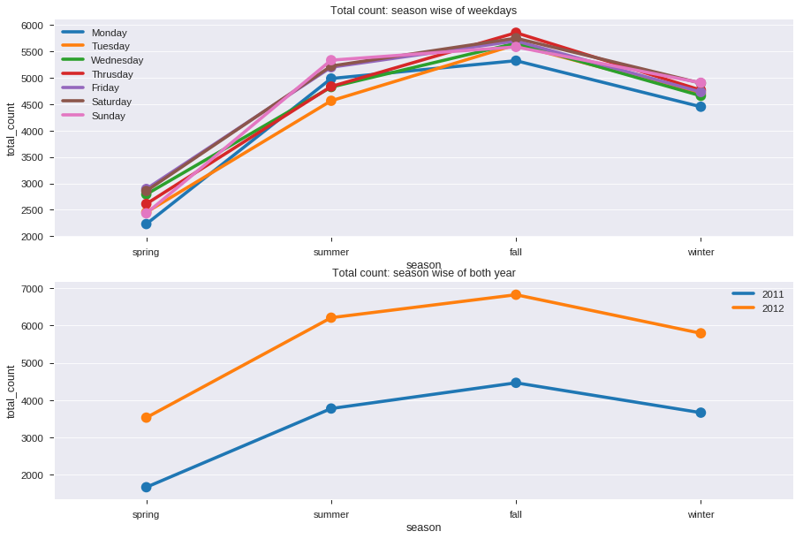

**Observation**:

* Casual count increases over the weekend, on an average.
* Registered count increases over the weekday on an average.

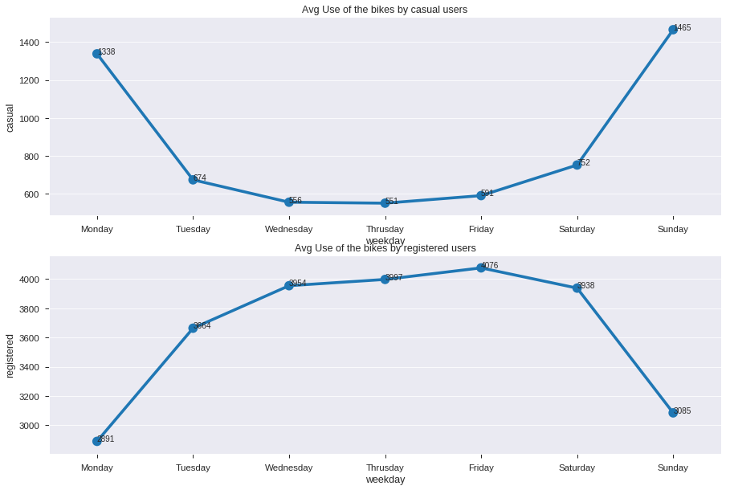

#### B. Continuous Features

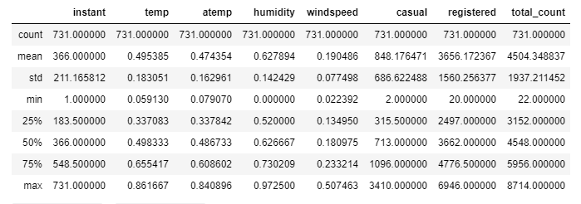

**Key Findings:**

1. Temp, Atemp looks normally distributed.
2. A strong correlation can be seen for temp and atemp.
3. windspeed, humidity, temp and atemp are all normalized in the dataset already.
4. With increase in temperature, the count of bike rentals increases as shown in reg plot.
5. temp has got positive correlation with count as people like to travel more when the sky is clear.
6. humidity is inversely related to count as expected as when weather is humid people will not like to travel on a bike.
7. windspeed is also having a negative correlation with "count".
8. "atemp" and "temp" variable has got strong correlation with each other. During model building any one of the variables must be dropped since they will exhibit multicollinearity in the data.
9. "weather condition" and count are inversely related. This is because for our data as weather increases from (1 to 4) implies that weather is getting more worse and so lesser people will rent bikes.
10. "registered" and count are highly related which indicates that most of the bikes that are rented are registered.
11. "Casual" and "Registered" are also not considered since they are leakage variables in nature and need to drop during model building to avoid bias. (casual + registered = count).
12. "instant" variable can also be dropped during model building as it indicates index.

**Observation**: Here we considered "count" vs "temp", "humidity", "windspeed".

1. A +ve correlation with temperature was observed (sky is clear with increase in temperature)
2. A -ve correlation with humidity and windspeed was observed as people avoid travelling when weather is very windy or humid.

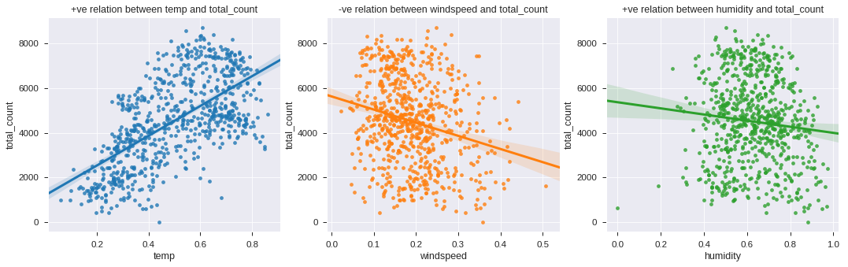

Correlation matrix is telling about linear relationship between attributes and help us to build better models. From the correlation plot, we can observe that some features are positively correlated, and some are negatively correlated to each other. The temp and atemp are highly positively correlated to each other, it means that both are carrying same information. So, we are going to ignore atemp, casual and registered variable for further analysis.

**Observation**:

* Temp and atemp are highly correlated.
* Casual + registered = Total count

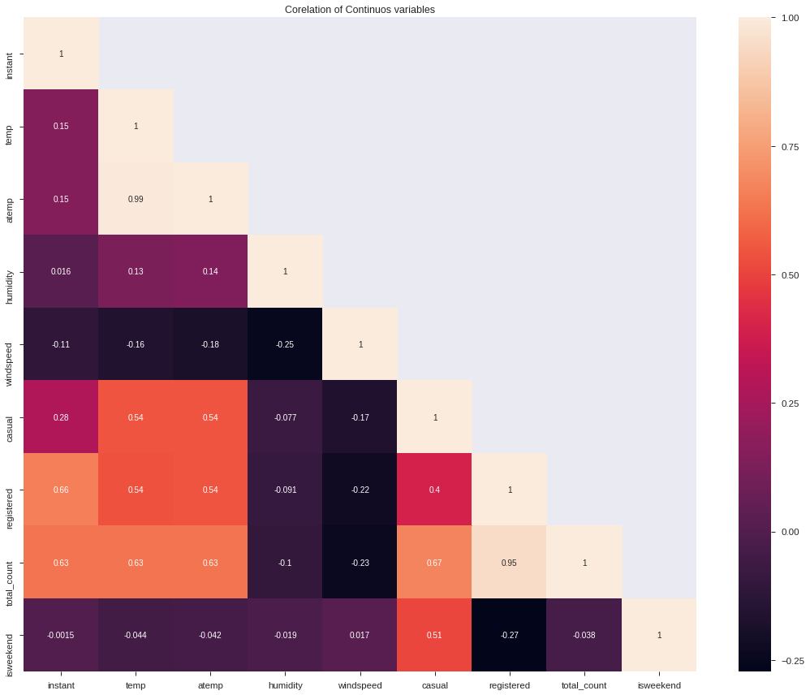

**Observation**:

* A +ve correlation between humidity and temperature was observed (as temp increases the amount of water vapour present in the air also increases)
* A -ve correlation between windspeed with humidity and temperature was observed (as wind increases, it draws heat from the body, thereby temperature and humidity decreases)

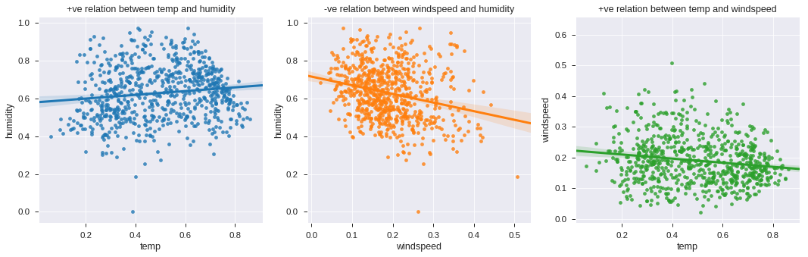

**Observation**:

* Temp and atemp are highly correlated.
* Windspeed and humidity have skewed distribution.
* One point seems to be outlier in temp and atemp correlation plot.
* Possibility of outliers in Windspeed and humidity.

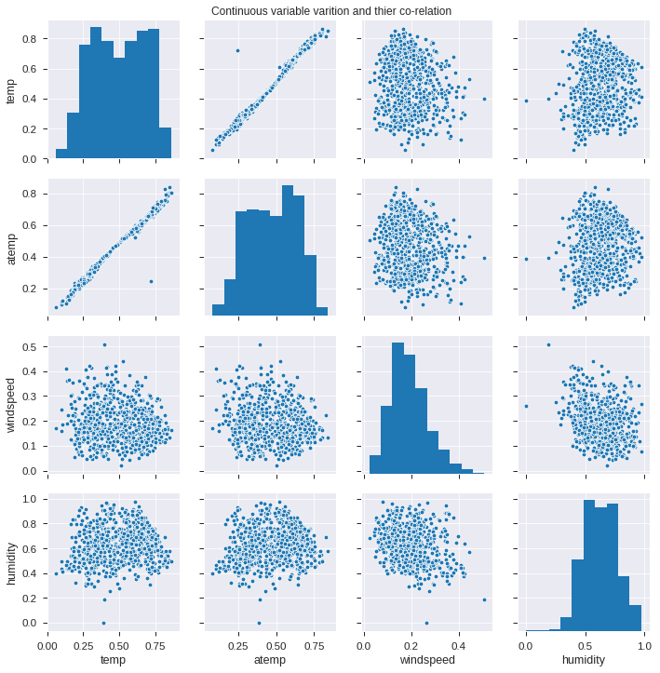

## 2.1.2.2 Outlier Analysis

A boxplot is a graph that gives you a good indication of how the values in the data are spread out. Although boxplots may seem primitive in comparison to a histogram or density plot, they have the advantage of taking up less space, which is useful when comparing distributions between many groups or datasets.

**Key Findings:**

* Few bivariate outliers were observed from the box plots and pair plots.

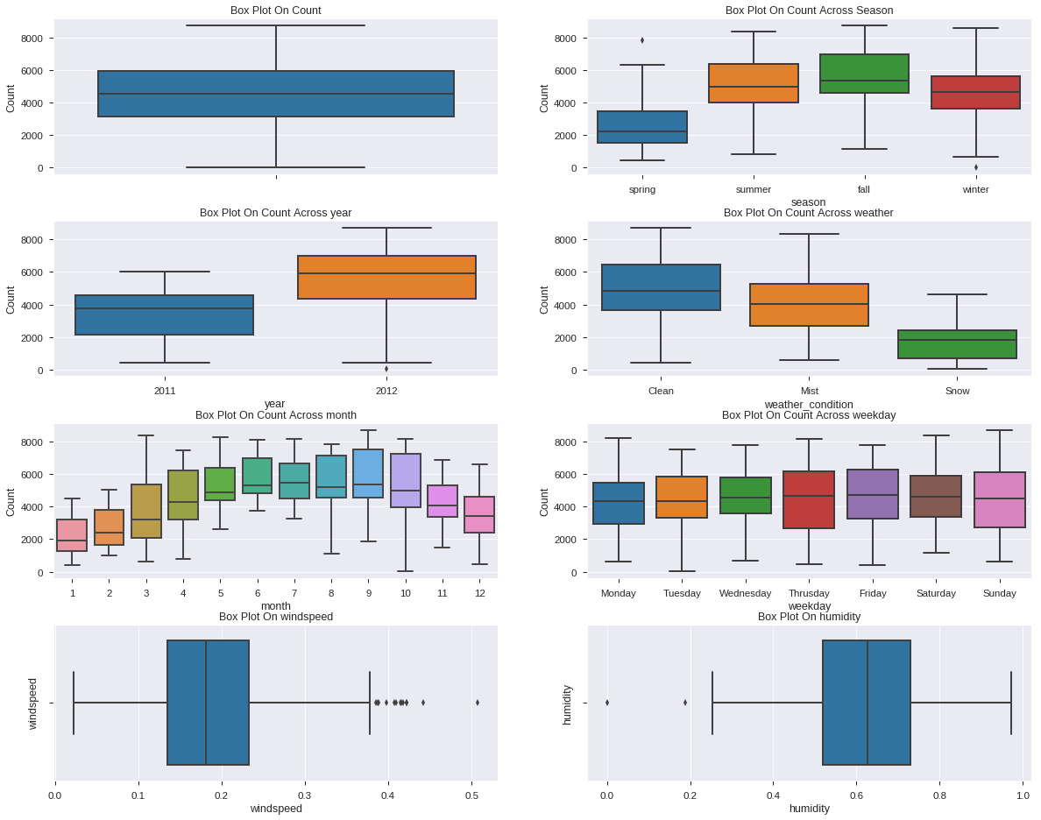

**Observations**:

1. From the box plot, we can observe that few outliers are present in normalized windspeed and humidity variable.
2. Data need to be free from outliers and need to be scaled before applying any outlier sensitive model algorithms.

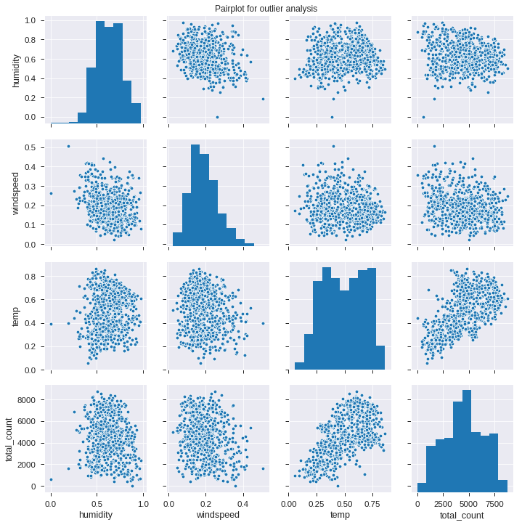

**Observations**:

1. From the pair plot, we can observe that no outliers are present in normalized temp, but few outliers are present in normalized windspeed and humidity variable.
2. Data need to be free from outliers and need to be scaled before applying any outlier sensitive model algorithms.

# 2.2 Data Preprocessing and Analysis

## 2.2.1 Outlier Handling

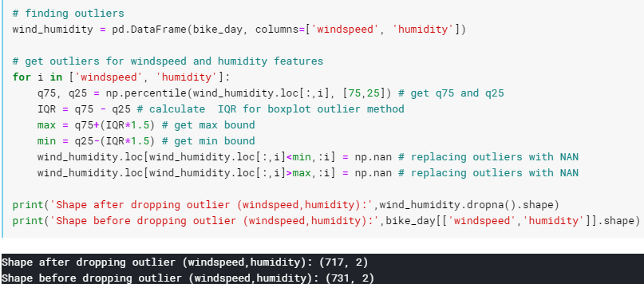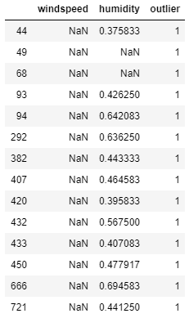

**Observation:**

1. After separating outliers and inliers with IQR method we found 25 rows have outliers.
2. Since, 25 is not very significant, we will drop those 25 rows.

## 2.2.2 Feature Selection

Feature selection is very important for modelling the dataset. Every dataset has good and unwanted features. The unwanted features will affect performance of model, so we must delete those features. We must select best features by using ANOVA, Chi-Square test and correlation matrix statistical techniques and so on. In this, we are selecting best features by using Correlation matrix.

1. "atemp" and "temp" variable has got strong correlation with each other. During model building any one of the variables must be dropped since they will exhibit multicollinearity in the data.
2. “datetime” variable only contains date which is not important features for prediction.
3. "weather condition" and count are inversely related. This is because for our data as weather increases from (1 to 4) implies that weather is getting more worse and so lesser people will rent bikes.
4. "registered" and count are highly related which indicates that most of the bikes that are rented are registered.
5. "Casual" and "Registered" are also not considered since they are leakage variables in nature and need to drop during model building to avoid bias. (casual + registered = count).
6. "instant" variable can also be dropped during model building as it indicates index.

Python:

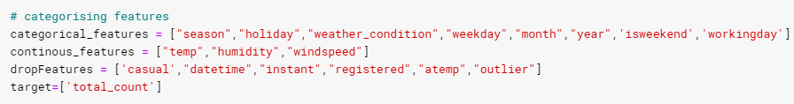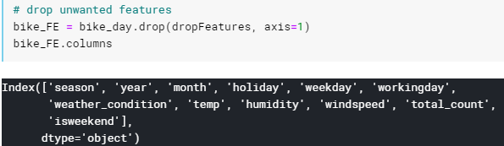

## 2.2.3 Feature Engineering

1. A new feature “isweekend” was created, which denotes Sat or Sun as 1, and 0 otherwise.

Python:

R:

1. We will use pd.get_dummies () function for One-Hot Encoding the categorical features and fastDummies function in R, below is the Python and R code:

Python:

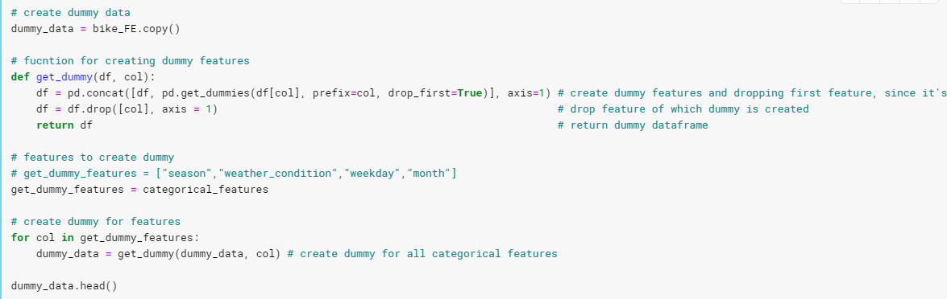

R:

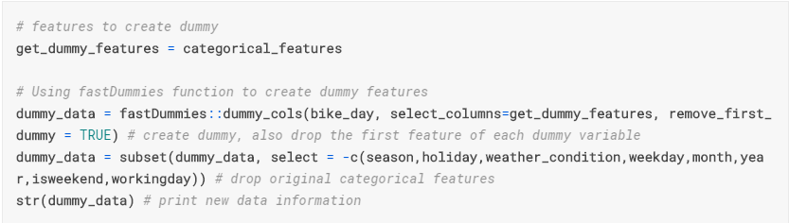

Python Output R Output

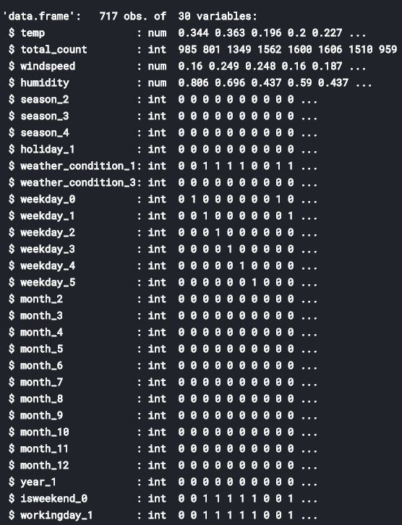

# 2.3 Modeling

## 2.3.1 Model Selection

Model selection is the process of choosing between different machine learning approaches - e.g. SVM, logistic regression, linear regression, etc. - or choosing between different hyperparameters or sets of features for the same machine learning approach - e.g. deciding between the polynomial degrees/complexities for linear regression.

The dependent variable can fall in either of the four categories:

Nominal, Ordinal, Interval, Ratio

If the dependent variable is Nominal the only predictive analysis that we can perform is Classification, and if the dependent variable is Interval or Ratio, the normal method is to do a Regression analysis, or classification after binning.

We started our model building from the simplest to more complex. Therefore, we use Simple Linear Regression first as our base model.

We used the following models for the evaluation of the right algorithm:

1. Simple Linear Regression
2. Regularization Regression: LASSO, Ridge, and ElasticNet
3. Random Forest Regression
4. Gradient Boosting Machine

## 2.3.2 Multilinear & Regularization model: Linear Regression| Ridge| Lasso| ElasticNet

#### Without StandardScale

Python:

R:

* Regularization LASSO, Ridge, ElasticNet with cross validation and hyper-tuning parameter.

**Regularization:** This is a form of regression, that constrains/ regularizes or shrinks the coefficient estimates towards zero. In other words, **this technique discourages learning a more complex or flexible model, to avoid the risk of overfitting.**

1. **Ridge Regression:**
   * Performs L2 regularization, i.e. adds penalty equivalent to **square of the magnitude** of coefficients
   * Minimization objective = LS Obj + α * (sum of square of coefficients)
2. **Lasso Regression:**
   * Performs L1 regularization, i.e. adds penalty equivalent to **absolute value of the magnitude** of coefficients
   * Minimization objective = LS Obj + α * (sum of absolute value of coefficients)

Note that here ‘LS Obj’ refers to ‘least squares objective’, i.e. the linear regression objective without regularization.

1. **ElasticNet Regression:**
   * ElasticNet is hybrid of Lasso and Ridge Regression techniques. It is trained with L1 and L2 prior as regularizes.
   * Elastic-net is useful when there are multiple features which are correlated. Lasso is likely to pick one of these at random, while elastic-net is likely to pick both.

[elastic net regression](https://www.analyticsvidhya.com/wp-content/uploads/2015/08/Elastic_Net.png)

* + A practical advantage of trading-off between Lasso and Ridge is that, it allows Elastic-Net to inherit some of Ridge’s stability under rotation.

#### With StandardScale: Python

Python:



* Regularization LASSO, Ridge, ElasticNet with cross validation and hyper-tuning parameter.

We have taken the regularization models and fitted a pipeline with StandardScale(), and applied gridSearchCV(), provided with hyper-parameters, for getting optimal model.

Grid search is the process of performing hyper parameter tuning in order to determine the optimal values for a given model. This is significant as the performance of the entire model is based on the hyper parameter values specified.

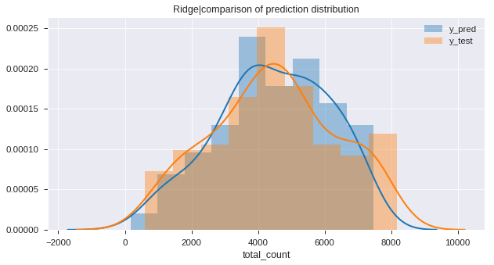 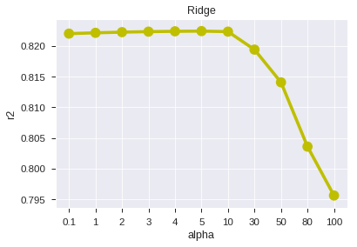

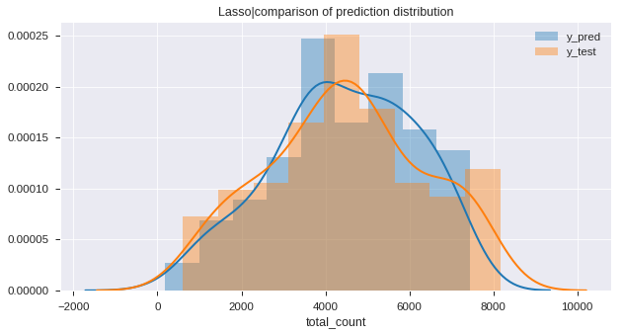 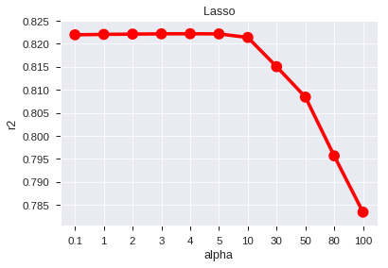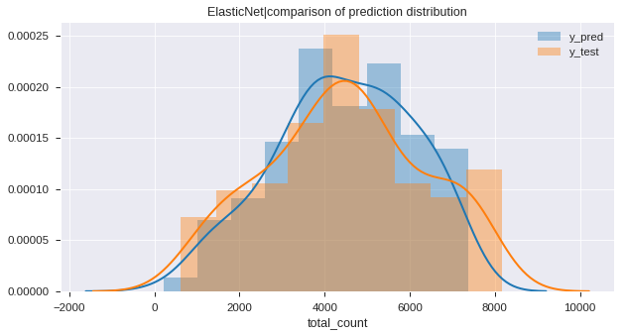 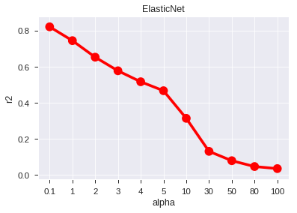

## 2.3.3 Random Forest

A Random Forest is an ensemble technique capable of performing both regression and classification tasks with the use of multiple decision trees and a technique called **Bootstrap Aggregation**, commonly knownas**bagging**. What is bagging you may ask? Bagging, in the Random Forest method, involves training each decision tree on a different data sample where sampling is done with replacement.

Python:

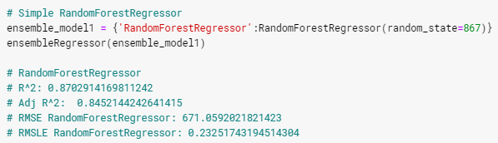

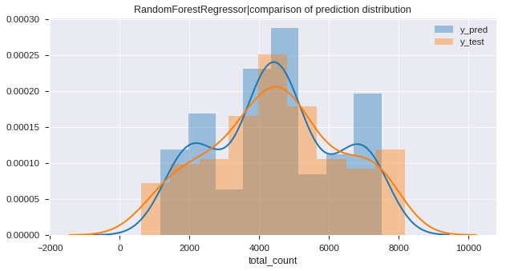

R:

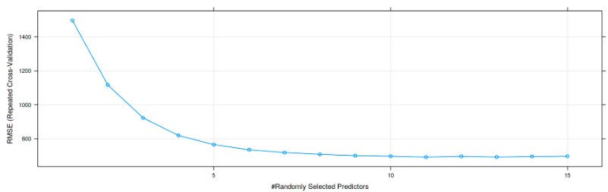

## 2.3.4 Gradient Boosting

**Gradient boosting** is a [machine learning](https://en.wikipedia.org/wiki/Machine_learning) technique for [regression](https://en.wikipedia.org/wiki/Regression_(machine_learning)) and [classification](https://en.wikipedia.org/wiki/Classification_(machine_learning)) problems, which produces a prediction model in the form of an [ensemble](https://en.wikipedia.org/wiki/Ensemble_learning) of weak prediction models, typically [decision trees](https://en.wikipedia.org/wiki/Decision_tree_learning). It builds the model in a stage-wise fashion like other [boosting](https://en.wikipedia.org/wiki/Boosting_(machine_learning)) methods do, and it generalizes them by allowing optimization of an arbitrary [differentiable](https://en.wikipedia.org/wiki/Differentiable_function) [loss function](https://en.wikipedia.org/wiki/Loss_function).

A big insight into bagging ensembles and random forest was allowing trees to be greedily created from subsamples of the training dataset. This same benefit can be used to reduce the correlation between the trees in the sequence in gradient boosting models. This variation of boosting is called **stochastic gradient boosting**.

*At each iteration a subsample of the training data is drawn at random (without replacement) from the full training dataset. The randomly selected subsample is then used, instead of the full sample, to fit the base learner.*

— [Stochastic Gradient Boosting](https://statweb.stanford.edu/~jhf/ftp/stobst.pdf)

Python:

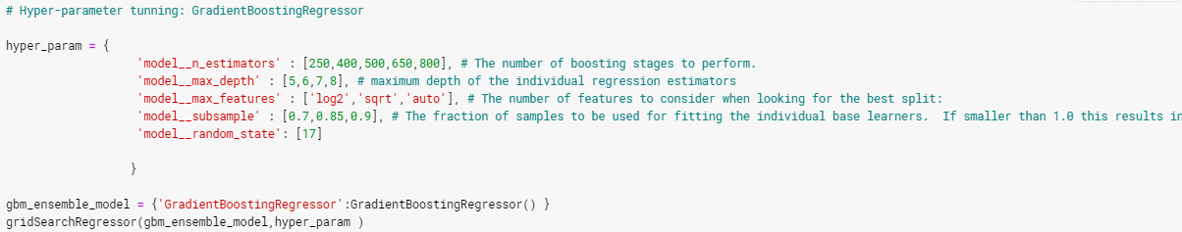

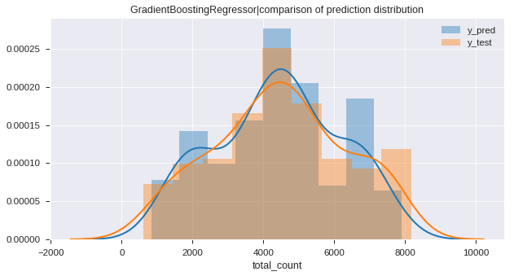

R:

# CHAPTER 3

Conclusion

# 3.1 Model Evaluation

Now, we have 6 models for predicting the target variable, and we need to decide which model is better for this project. There are many metrics used for model evaluation.

There are several criteria that exist for evaluating and comparing models. We can compare the models using any of the following criteria:

1. Predictive Performance
2. Interpretability
3. Computational Efficiency

In our case of Bike Data, the latter two, Interpretability and Computation Efficiency, do not hold much significance. Therefore, we will use Predictive performance as the criteria to compare and evaluate models. Predictive performance can be measured by comparing Predictions of the models with real values of the target variables and calculating some average error measure.

1. **R-squared or Coefficient of Determination (𝑹𝟐)**: -

It defines the degree to which the variance in the dependent variable (or target) can be explained by the independent variable (features). It explains the how much variance of dependent variable which is contributed by all the independent variables.

Here, 𝑦 ̅𝑡𝑟𝑢𝑒 is the mean of true dependent variable values

1. **Adj R-squared: -**

Adjusted R-squared measures the variation in the dependent variable (or target), explained by only the features which are helpful in making predictions. Unlike R-squared, the Adjusted R-squared would penalize you for adding features which are not useful for predicting the target.

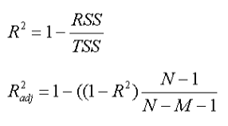

Here R^2 is the r-squared calculated, N is the number of rows and M is the number of columns. As the number of feature increases, the value in the denominator decreases.

* If the R2 increases by a significant value, then the adjusted r-squared would increase.
* If there is no significant change in R2, then the adjusted r2 would decrease.

1. **Root Mean Square Error** (RMSE): - It is the square root of the mean of the square of difference between the true and predicted dependent variable values.

1. **Root Mean Square Log Error (**RMSLE): -

*RMSLE penalizes an under-predicted estimate greater than an over-predicted estimate.*

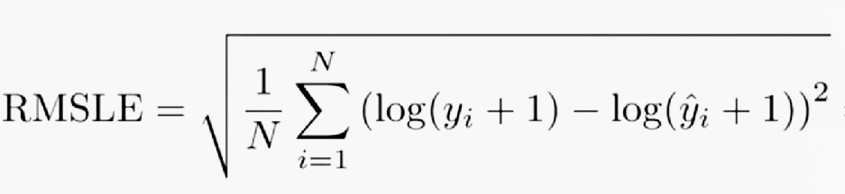

When the differences from predicted and actuals are large the log function helps normalizing this.

By applying logarithms to both prediction and actual numbers, we’ll get smoother results by reducing the impact of larger x, while emphasize of smaller x.

RMSLE measures the ratio between actual and predicted.

The problem with R-squared is that it will either stay the same or increase with addition of more variables, even if they do not have any relationship with the output variables. This is where “Adjusted R square” comes to help. Adjusted R-square penalizes you for adding variables which do not improve your existing model. Hence, if you are building Linear regression on multiple variable, it is always suggested that you use **Adjusted R-squared to judge goodness of model**. In case you only have one input variable, R-square and Adjusted R squared would be exactly same. Typically, the more non-significant variables you add into the model, the gap in R-squared and Adjusted R-squared increases.

In case of RMSLE, we take the log of the predictions and actual values. So basically, what changes is the variance that we are measuring. RMSLE is usually used when we don't want to penalize huge differences in the predicted and the actual values when both predicted and true values are huge numbers.

1. If both predicted and actual values are small: RMSE and RMSLE is same.
2. If either predicted or the actual value is big: RMSE > RMSLE
3. If both predicted and actual values are big: RMSE > RMSLE (RMSLE becomes almost negligible)

Python:

R:

Python:

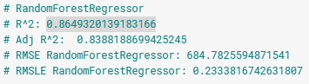

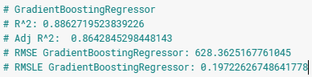

R:

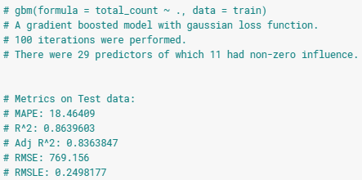

## 3.1.1 R-squared & Adj R-squared

Python:

|  |  |  |
| --- | --- | --- |
| Model | R-squared | Adj R-squared |
| Linear Regression | 0.8503150391570844 | 0.8213759467274541 |
| LASSO Regression | 0.8505544480598202 | 0.8215178229750227 |
| Ridge Regression | 0.8502971862653109 | 0.8213546422766044 |
| ElasticNet Regression | 0.8473885489959245 | 0.7243433797638379 |
| Random Forest Regression | 0.8715849042781012 | 0.8467579857718674 |
| Gradient Boosting Regression | 0.8870138124626565 | 0.8651698162054368 |

R:

|  |  |  |
| --- | --- | --- |
| Model | R-squared | Adj R-squared |
| Linear Regression | 0.8717872 | 0.8457981 |
| LASSO Regression | 0.8718666 | 0.8458936 |
| Ridge Regression | 0.8597313 | 0.8312985 |
| ElasticNet Regression | 0.8694822 | 0.8430259 |
| Random Forest Regression | 0.9099247 | 0.8916662 |
| Gradient Boosting Regression | 0.9137555 | 0.8962735 |

## 3.1.2 Root Mean Squared Error (RMSE) & Root Mean Squared Log Error

Python:

|  |  |  |
| --- | --- | --- |
| Model | RMSE | RMSLE |
| Linear Regression | 720.8842925663195 | 0.24655168053752335 |
| LASSO Regression | 720.3075640121864 | 0.24420533245983528 |
| Ridge Regression | 720.9272811386522 | 0.24640128765416605 |
| ElasticNet Regression | 727.8971844088097 | 0.24186048423041664 |
| Random Forest Regression | 667.7048312259761 | 0.2349906934957484 |
| Gradient Boosting Regression | 626.3097260903672 | 0.2143924133958078 |

R:

|  |  |  |
| --- | --- | --- |
| Model | RMSE | RMSLE |
| Linear Regression | 746.702 | 0.2219201 |
| LASSO Regression | 746.4707 | 0.2208965 |
| Ridge Regression | 781.0196 | 0.2163474 |
| ElasticNet Regression | 753.3842 | 0.215776 |
| Random Forest Regression | 625.8704 | 0.1940767 |
| Gradient Boosting Regression | 612.4171 | 0.2049584 |

# 3.2 Model Selection

We have implemented 6 models and out of 6 ensemble models performing best on our error metrics. Followings are the conclusion we made:

* Gradient Boosting model is performing best in both python and R.

|  |  |  |
| --- | --- | --- |
|  | **Python** | **R** |
| R-squared | 0.887013 | 0.913755 |
| Adj R-squared | 0.865169 | 0.896273 |
| RMSE | 626.3097 | 612.4171 |
| RMSLE | 0.214392 | 0.204958 |

* the dataset contained very less samples (around 731), due to which a large RMSE value was observed while training different models.
* by increasing the no of samples, the model can learn better, and overall error will be reduced.
* **temperature, year, season, humidity,** and **weather** appeared to be the top 5 features affecting bike rental count.

# Appendix A - Extra Figures

Python:

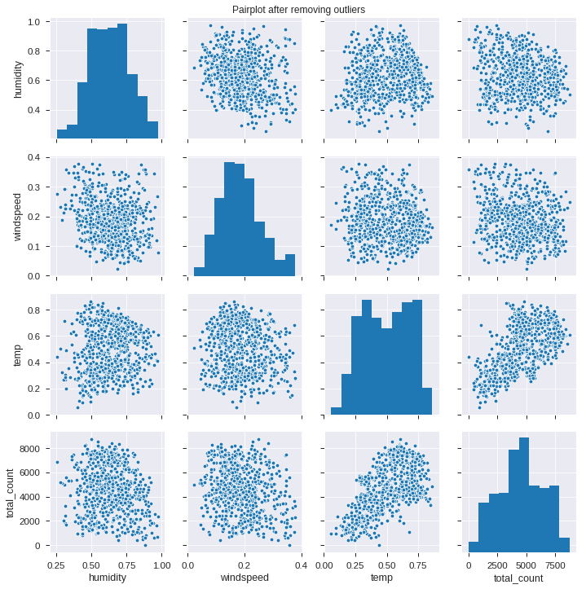

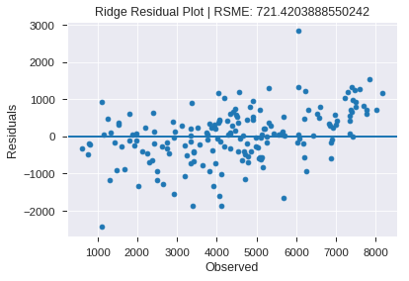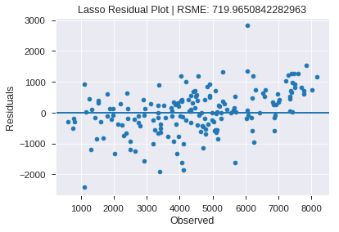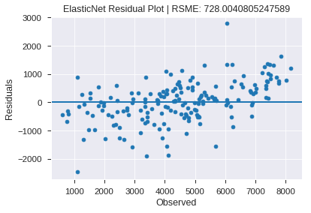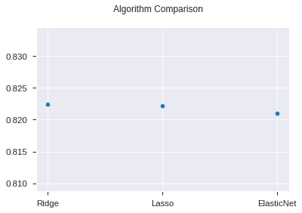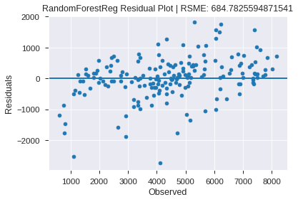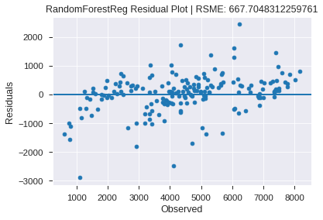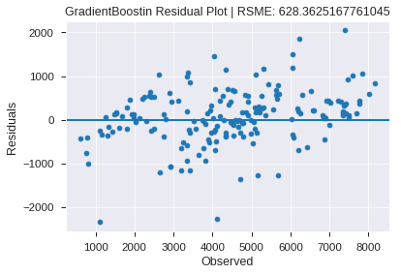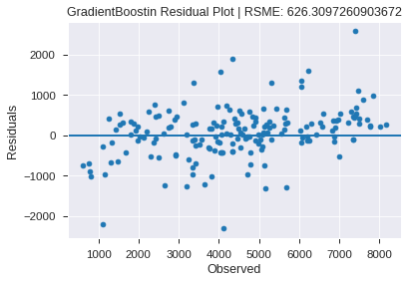

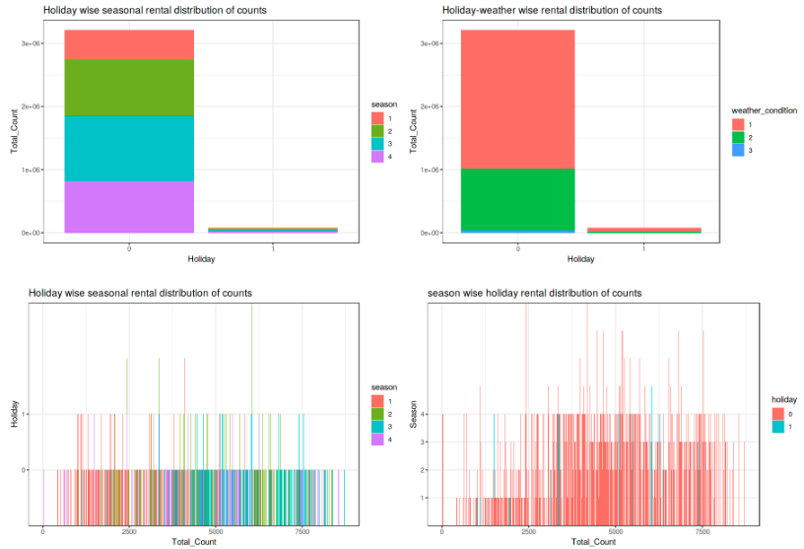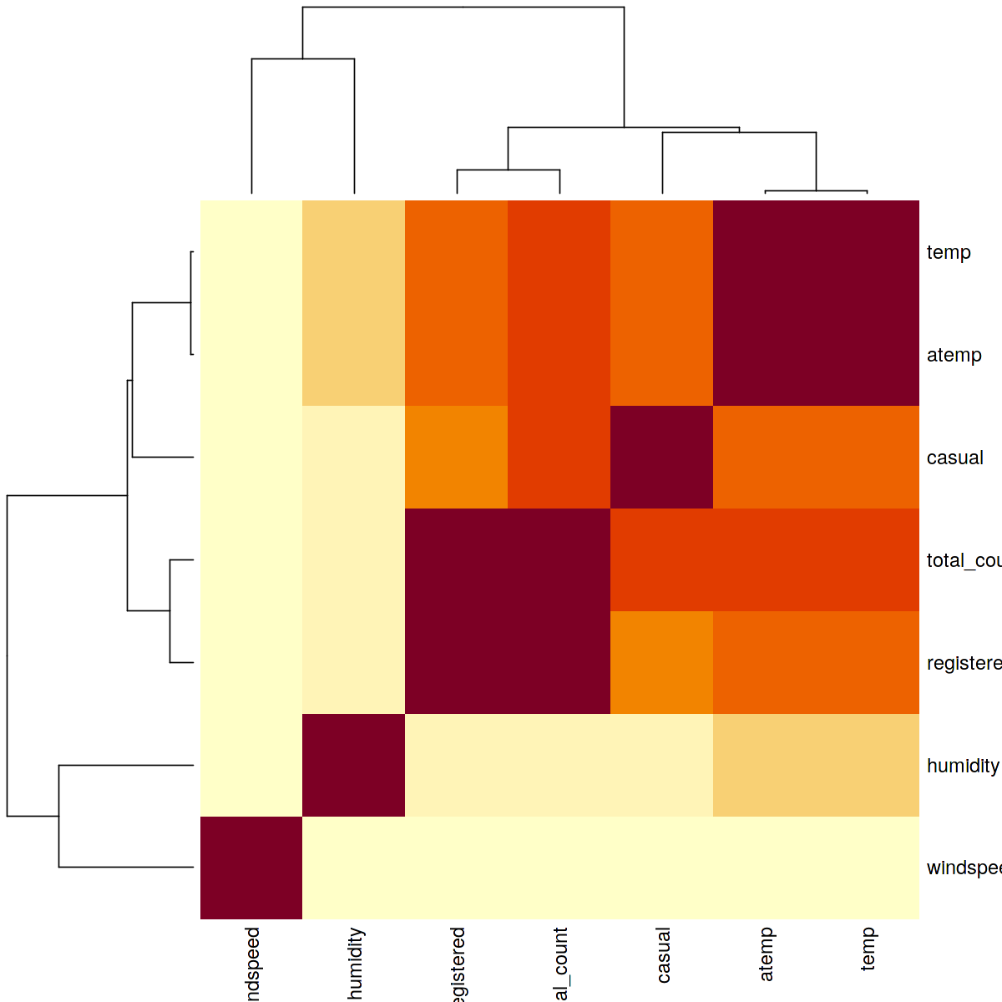

# Appendix B – Complete Python and R Code

## Python Code

# %% [markdown]

# ### **Contents**

#

# 1 Introduction

# 1.1 Problem Statement

# 1.2 Data

# 2 Methodology

# 2.1 Exploratory Data Analysis

# 2.1.1 Descriptive Analysis

# 2.1.1.1 Features Analysis

# 2.1.1.1 Missing Value Analysis

# 2.1.1.3 Target Variable Analysis

# 2.1.2 Visualization

# 2.1.2.1 Attributes Distributions and trends

# 2.1.2.2 Outlier Analysis

# 2.2 Data Preprocessing and Analysis

# 2.2.1 Outlier Handling

# 2.2.2 Feature Selection

# 2.2.3 Feature Engineering

# 2.3 Modeling

# 2.3.1 Random Sampling

# 2.3.2 Multilinear & Regularization Regression

# 2.3.3 Random Forest

# 2.3.4 Gradient Boosting

# 4 Final Model

# %% [markdown]

# # 1. Introduction

#

# The usage of bicycles as a mode of transportation has gained traction in recent years due to with environmental and health issues. The cities across the world have successfully rolled out bike sharing programs to encourage usage of bikes. Under such programs, the riders can rent bicycles using manual or automated stalls spread across the city for defined periods. In most cases, riders can pick up bikes from one location and returned them any other designated place.

#

# The bike sharing programs from across the world are hotspots of all sorts of data, ranging from travel time, start and end location, demographics of riders, and so on. This data along with alternate sources of information such as weather, traffic, terrain, season and so on.

#

#

# ## 1.1 Problem Statement

#

# The objective of this Case is to Predication of bike rental count on daily based on the environmental and seasonal settings. The objective is to forecast bike rental demand of Bike sharing program in Washington, D.C based on historical usage patterns in relation with weather, environment and other data. We would be interested in predicting the rentals on various factors including season, temperature, weather and building a model that can successfully predict the number of rentals on relevant factors.

#

# ## 1.2 Data

#

# This dataset contains the seasonal and weekly count of rental bikes between years 2011 and 2012 in Capital bikeshare system with the corresponding temperature and humidity information. Bike sharing systems are a new way of traditional bike rentals. The whole process from membership to rental and return has become automatic. The data was generated by 500 bike-sharing programs and was collected by the Laboratory of Artificial Intelligence and Decision Support (LIAAD), University of Porto. Given below is the description of the data which is a (731, 16) shaped data.

#

# ### short description of features

# 1. instant: Record index

# 1. dteday: Date

# 1. season: Season (1:spring, 2:summer, 3:fall, 4:winter)

# 1. yr: Year (0: 2011, 1:2012)

# 1. mnth: Month (1 to 12)

# 1. holiday: weather day is holiday or not (extracted from Holiday Schedule)

# 1. weekday: Day of the week

# 1. workingday: If day is neither weekend nor holiday it's 1, otherwise is 0.

# 1. weathersit: (extracted from Freemeteo)

# >1. Clear, Few clouds, Partly cloudy, Partly cloudy

# >2. Mist + Cloudy, Mist + Broken clouds, Mist + Few clouds, Mist

# >3. Light Snow, Light Rain + Thunderstorm + Scattered clouds, Light Rain + Scattered clouds

# >4. Heavy Rain + Ice Pallets + Thunderstorm + Mist, Snow + Fog

# 1. temp: Normalized temperature in Celsius.

# 1. atemp: Normalized feeling temperature in Celsius.

# 1. hum: Normalized humidity. The values are divided to 100 (max)

# 1. windspeed: Normalized wind speed. The values are divided to 67 (max)

# 1. casual: count of casual users

# 1. registered: count of registered users

# 1. cnt: count of total rental bikes including both casual and registered

# %% [code]

# Ignore the warnings

import warnings

warnings.filterwarnings('always')

warnings.filterwarnings('ignore')

# data visualisation and manipulation

import os, sys

import numpy as np # linear algebra

import pandas as pd # data processing, CSV file I/O (e.g. pd.read_csv)

import seaborn as sns # visualization

import matplotlib.pyplot as plt # visualization

import random

import pandas_profiling as pp

# configure font_scale and linewidth for seaborn

sns.set_context('paper', font_scale=1.3, rc={"lines.linewidth": 2})

# preprocessing and metrics

from sklearn.preprocessing import StandardScaler

from sklearn.metrics import mean_squared_error, mean_squared_log_error, make_scorer

# model selection

from sklearn.model_selection import train_test_split

from sklearn.model_selection import GridSearchCV

# regresson model

from sklearn.linear_model import LinearRegression, Ridge, Lasso, ElasticNet

from sklearn.ensemble import RandomForestRegressor, GradientBoostingRegressor

# pipeline builder

from sklearn.pipeline import Pipeline, make_pipeline

# %% [code]

# list files in dir

print(os.listdir('../input/bike-sharing-dataset/'))

# %% [code]

# load data

bike_day = pd.read_csv('../input/bike-sharing-dataset/day.csv')

print('Shape of the data:', bike_day.shape) # shape of data

bike_day.head() # top 5 rows of data

# %% [code]

# data informations

bike_day.info()

# %% [code]

# renaming the columns

bike_day.rename(columns={'dteday':'datetime','yr':'year','mnth':'month','weathersit':'weather_condition','hum':'humidity','cnt':'total_count'},inplace=True)

#Type casting the datetime and numerical attributes to category

bike_day['datetime']=pd.to_datetime(bike_day.datetime) # datetime conversion

bike_day['season']=bike_day.season.astype('category') # categorical conversion

bike_day['year']=bike_day.year.astype('category')

bike_day['month']=bike_day.month.astype('category')

bike_day['holiday']=bike_day.holiday.astype('category')

bike_day['weekday']=bike_day.weekday.astype('category')

bike_day['workingday']=bike_day.workingday.astype('category')

bike_day['weather_condition']=bike_day.weather_condition.astype('category')

bike_day.info() # data information after typecasting

# %% [markdown]

# # 2. Methodology

#

# ## 2.1 Exploratory Data Analysis

# In this section, we'll explore the attributes and data values. Familiarity with data will provide more insight knowledge for data pre-processing, analysize how to use graphical and numerical techniques to begin uncovering the structure of our data.

#

# By looking at data I came across that data is without any missing values however, casual user variable has outliers in it. Visualizations of the bike rental count base on the season, month, day of the week, the type of day, is it a weekday, is it a holiday, and the type of weather, then calculating the mean of temperature, humidity, wind speed and rental count. The purpose of this summarization is to ?nd a general relationship between variables regardless of which year the data is from.

#

# ### 2.1.1 Descriptive Analysis

# %% [markdown]

# ### 2.1.1.1 Feature Analysis

#

# #### Generating profile report using pandas_profiling

# For each column the following statistics are presented in an interactive HTML page:

# * Essentials: type, unique values, missing values

# * Quantile statistics : minimum value, Q1, median, Q3, maximum, range, interquartile range

# * Descriptive statistics : mean, mode, standard deviation, sum, median absolute deviation, coefficient of variation, kurtosis, skewness

# * Most frequent values

# * Histogram

# * Correlations highlighting of highly correlated variables, Spearman and Pearson matrixes

# %% [code]

# profile report generated in the saved repository as a html file

profile = pp.ProfileReport(bike_day)

profile.to_file("profile.html") # saving profile report as html doc

profile

# %% [markdown]

# Click profile to open profile report in new tab.

# <button><a href='./profile.html' ><b>profile</b></a></button>

# %% [code]

#diffrent value counts in each categorical features

categorical_col = ['season', 'year', 'month', 'holiday', 'weekday','workingday', 'weather_condition']

end='\n'+'*'*10+'\n' # end line seperator

for col in categorical_col:

print(col,':\n',bike_day[col].value_counts(),end=end) # listing frequency of each value for all of the categorical features

# %% [markdown]

# ### 2.1.1.2 Missing Value Analysis

# %% [code]

# missing value checking

print('Number of missing values:\n',bike_day.isnull().sum())

# description

bike_day.describe()

# %% [markdown]

# ### 2.1.1.3 Sneakpeak for target variable

#

# Target variable (total_count) distribution

# > target variable is normally distributed, no skewness observed.

# %% [code]

# Distribution of target variable

_ , ax = plt.subplots(1,2, figsize=(15,5)) # 1 row 2 column subplot

sns.distplot(bike_day.total_count, bins=50, ax=ax[0]) # dependent variable distribution plot with 50 bins

ax[0].set_title('Dist plot')

ax[1] = bike_day.total_count.plot(kind='kde') # dependent variable KDE plot

ax[1].set_title('KDE plot')

# %% [markdown]

# ### 2.1.2 Visualization

#

# It is the process of projecting the data, or parts of it, into Cartesian space or into abstract images. With a little domain knowledge, data visualizations can be used to express and demonstrate key relationships in plots and charts that are more visceral to yourself and stakeholders than measures of association or significance. In the data mining process, data exploration is leveraged in many different steps including preprocessing, modeling, and interpretation of results.

# One of our main goals for visualizing the data here, is to observe which features are most intiuitive in predicting target. The other, is to draw general trend, may aid us in model selection and hyper parameter selection.

#

#

# ### 2.1.2.1 Attribute Distribution and Trends

#

# #### Categorical features

#

#

# %% [code]

categorical_features = categorical_col

print('Categorical features :',', '.join(categorical_features))

# %% [code]

# Holiday wise yearly count of bike rental

bike_day[['season','year', 'total_count', 'holiday']].groupby([ 'year', 'holiday']).sum()

# %% [code]

# weather condition wise count of bike rental

bike_day[['weather_condition', 'total_count']].groupby(['weather_condition']).sum()

# %% [code]

# weather condition wise avg_count of bike rental

bike_day[['weather_condition', 'total_count']].groupby(['weather_condition']).mean().round().astype(int)

# %% [code]

# weather condition wise avg_count of bike rental

ax = sns.barplot(x='weather_condition',y='total_count',data=bike_day, ci=None)

ax.set_title("Weather_condition: avg_count of bike rental") # set title

ax.set_xticklabels(['Clear', 'Mist', 'Snow']) # set x-tick labels

plt.show()

# %% [code]

f, (ax1, ax2) = plt.subplots(nrows=1, ncols=2, figsize=(13, 6)) # 1 row 2 column subplot

# Counts of Bike Rentals by season

ax1 = bike_day[['season','total_count']].groupby(['season']).sum().reset_index().plot(kind='bar',legend = False, title ="Counts of Bike Rentals by season", stacked=True, fontsize=12, ax=ax1)

ax1.set_xlabel("season", fontsize=12) # set x-axis labels

ax1.set_ylabel("Count", fontsize=12) # set y-axis labels

ax1.set_xticklabels(['spring','summer','fall','winter']) # set x-tick labels

# Counts of Bike Rentals by weather condition

ax2 = bike_day[['weather_condition','total_count']].groupby(['weather_condition']).sum().reset_index().plot(kind='bar', legend = False, stacked=True, title ="Counts of Bike Rentals by weather condition", fontsize=12, ax=ax2)

ax2.set_xlabel("weather_condition", fontsize=12) # set x-axis labels

ax2.set_ylabel("Count", fontsize=12) # set y-axis labels

ax2.set_xticklabels(['1: Clear','2: Mist','3: Light Snow']) # set x-tick labels

f.tight_layout()

# %% [code]

# Count of bike on workingdays/holidays for each season

bike_day[['season','year', 'total_count', 'holiday']].groupby(['season', 'holiday']).sum().plot(kind='bar') # plotting bar graph

plt.title('Count of bike on workingdays/holidays for each season') # set title

# %% [code]

fig, (axs1,axs2,axs3) = plt.subplots(ncols=3, figsize=(18,5)) # 1 row 3 column subplot

# Total Count of bike for Each year

sns.barplot(x='year', y='total_count', data=bike_day, hue='season', ax=axs1, ci=None) # barplot

axs1.set_title('Total Count of bike for Each year') # set tilte

axs1.legend(['spring','summer','fall','winter']) # set legend

axs1.set_xticklabels(['2011', '2012']) # set x-tick label

# Casual Count of bike for Each year

sns.barplot(x='year', y='casual', data=bike_day, hue='season', ax=axs2, ci=None) # barplot

axs2.set_title('Casual Count of bike for Each year') # set title

axs2.legend(['spring','summer','fall','winter']) # set legend

axs2.set_xticklabels(['2011', '2012']) # set x-tick label

# Registered Count of bike for Each year

sns.barplot(x='year', y='registered', data=bike_day, hue='season', ax=axs3, ci=None) # barplot

axs3.set_title('Registered Count of bike for Each year') # set title

axs3.legend(['spring','summer','fall','winter']) # set legend

axs3.set_xticklabels(['2011', '2012']) # set x-tick label

# %% [code]

fig, (axs1,axs2,axs3) = plt.subplots(ncols=3, figsize=(18,5)) # 1 row 3 column subplot

# Total Count of bike, season wise

sns.barplot(x='season', y='total_count', data=bike_day, hue='weather_condition', ax=axs1, ci=None) # barplot

axs1.set_title('Total Count of bike, season wise') # set title

axs1.set_xticklabels(['spring','summer','fall','winter']) # set x-tick label

axs1.legend(labels=['Clean', 'Mist', 'Snow']) # set legend

# Casual Count of bike, season wise

sns.barplot(x='season', y='casual', data=bike_day, hue='weather_condition', ax=axs2, ci=None) # barplot

axs2.set_title('Casual Count of bike, season wise') # set title

axs2.set_xticklabels(['spring','summer','fall','winter']) # set x-tick label

axs2.legend(labels=['Clean', 'Mist', 'Snow']) # set legend

# Registered Count of bike, season wise

sns.barplot(x='season', y='registered', data=bike_day, hue='weather_condition', ax=axs3, ci=None) # barplot

axs3.set_title('Registered Count of bike, season wise') # set title

axs3.set_xticklabels(['spring','summer','fall','winter']) # set x-tick label

axs3.legend(labels=['Clean', 'Mist', 'Snow']) # set legend

# %% [code]

# Season-wise weekday bike count

plt.figure(figsize=(15,8)) # set figure size

sns.barplot(x='season', y='total_count', data=bike_day, hue='weekday', ci=None) # barplot

plt.legend(['Monday', 'Tuesday', 'Wednesday', 'Thrusday', 'Friday', 'Saturday', 'Sunday']) # set legend

plt.title('# Season-wise weekday bike count') # set title

plt.xticks(np.arange(4),['spring','summer','fall','winter']) # set x-tick label

# %% [code]

# Season-wise holiday bike count

plt.figure(figsize=(10,8)) # set figure size

sns.barplot(x='season', y='total_count', data=bike_day, hue='holiday', ci=None) # barplot

plt.legend(title='Day',labels= ['Holiday', 'Workday']) # set legend

plt.title('Season-wise holiday bike count') # set title

plt.xticks(np.arange(4),['spring','summer','fall','winter']) # set x-tick label

# %% [code]

#Consistency of Bike count on weekdays by monthly basis

plt.figure(figsize=(18,8)) # set figure size

sns.pointplot(x='month', y='total_count', data=bike_day, hue='weekday', ci=None) # pointplot

plt.legend(['Monday', 'Tuesday', 'Wednesday', 'Thrusday', 'Friday', 'Saturday', 'Sunday']) # set legend

plt.title('Bike count on weekdays by monthly basis') # set title

# %% [code]

_, ax=plt.subplots(nrows=2, ncols=1, figsize=(15,10))

# Total count: season wise of weekdays

sns.pointplot(x='season', y='total_count', data=bike_day, hue='weekday', ci=None, ax=ax[0]) # pointplot

ax[0].set_title('Total count: season wise of weekdays') # set title

ax[0].legend(['Monday', 'Tuesday', 'Wednesday', 'Thrusday', 'Friday', 'Saturday', 'Sunday']) # set legend

ax[0].set_xticklabels(['spring','summer','fall','winter']) # set x-tick label

# Total count: season wise of both year

sns.pointplot(x='season', y='total_count', data=bike_day, hue='year', ci=None, ax=ax[1]) # pointplot

ax[1].set_title('Total count: season wise of both year') # set title

ax[1].legend(['2011', '2012']) # set legend

ax[1].set_xticklabels(['spring','summer','fall','winter']) # set x-tick label

# %% [markdown]

# <b>Extract weekend column as a feature by using datetime feature.

# %% [code]

# Generally, 1-Monday and 0-Sunday in datetime , for weekend: Saturday-6 & Sunday-0

# creating new feature 'isweekend' using datetime feature and computing is that date is fall over the weekend

bike_day['isweekend']=bike_day['datetime'].apply( lambda x :1 if (x.weekday()==0) |(x.weekday()==6) else 0 ) # for weekday = 0 or 6, isweekend = 1 else 0

bike_day[bike_day['isweekend']==1]['weekday'].value_counts() # number of weekend days

# %% [code]

# Days wise average causal and registered bike count

casual_avg = bike_day.groupby(['weekday'])['casual'].mean().round().astype(int) # average casual rental on weekday

registered_avg = bike_day.groupby(['weekday'])['registered'].mean().round().astype(int) # average casual rental on weekday

print('Total count: casual {}, registered {}'.format(casual_avg.sum(), registered_avg.sum()))

# %% [code]

# Avg Use of the bikes by casual users on weekdays

_, ax=plt.subplots(nrows=2, ncols=1, figsize=(15,10)) # 2 row 1 col subplot

sns.pointplot(x='weekday', y='casual', data=bike_day, ci=None, ax=ax[0]) # pointplot

ax[0].set(title="Avg Use of the bikes by casual users") # set title

ax[0].set_xticklabels(['Monday', 'Tuesday', 'Wednesday', 'Thrusday', 'Friday', 'Saturday', 'Sunday']) # set x-tick label

for c in ax[0].collections:

for val,of in zip(casual_avg,c.get_offsets()):

ax[0].annotate(val, of) # set annotations for average of each weekday for casual rentals

# Avg Use of the bikes by registered users on weekday

sns.pointplot(x='weekday', y='registered', data=bike_day, ci=None, ax=ax[1]) # set pointplot

ax[1].set(title="Avg Use of the bikes by registered users") # set title

ax[1].set_xticklabels(['Monday', 'Tuesday', 'Wednesday', 'Thrusday', 'Friday', 'Saturday', 'Sunday']) # set x-tick label

for c in ax[1].collections:

for val,of in zip(registered_avg,c.get_offsets()):

ax[1].annotate(val, of) # set annotations for average of each weekday for registered rentals

# %% [markdown]

# #### Observation: all Categorical features

# - people like to rent bikes more when the sky is clear.

# - the count of number of rented bikes is maximum in fall (Autumn) season and least in spring season.

# - number of bikes rented per season over the years has increased for both casual and registered users.

# - registered users have rented more bikes than casual users overall.

# - casual users travel more over weekends as compared to registered users (Saturday / Sunday).

# - registered users rent more bikes during working days as expected for commute to work / office.

# - demand for bikes are more on working days as compared to holidays ( because majority of the bike users are registered )

#

# %% [markdown]

# #### Continuous features

#

# <b> A. Pairplot

# %% [code]

# Columns present in dataset after feature adding

bike_day.columns

# %% [code]

# Visualization of continuous variable varition and thier co-relation

ax = sns.pairplot(bike_day[['temp', 'atemp', 'windspeed', 'humidity']] ) # pairplot

ax.fig.suptitle('Continuous variable varition and thier co-relation', y=1.0) # set title

# %% [markdown]

# <b> B. Regression plot

#

# > <b> Regression plot of seaborn used to depict the relationship between continous features and target variable.</b>

#

# %% [code]

# Regresson plots between temp, windspeed and humidity against total_count

_ , ax = plt.subplots(1,3, figsize=(18,5)) # 1 row 3 column subplot

sns.regplot(x = 'temp', y='total_count', data=bike_day, ax= ax[0]) # Regression plot

ax[0].set_title('+ve relation between temp and total_count') # set title

sns.regplot(x = 'windspeed', y='total_count', data=bike_day, ax= ax[1]) # Regression plot

ax[1].set_title('-ve relation between windspeed and total_count') # set title

sns.regplot(x = 'humidity', y='total_count', data=bike_day, ax= ax[2]) # Regression plot

ax[2].set_title('+ve relation between humidity and total_count') # set title

# %% [markdown]

# #### Observation

# Here we considered "count" vs "temp", "humidity", "windspeed".

# - A +ve correlation with temperature was observed ( sky is clear with increase in temperature )

# - A -ve correlation with humidity and windspeed was observed as people avoid travelling when weather is very windy or humid.

# %% [code]

# Regresson plots between temp, windspeed and humidity to show thier relation with each other

_ , ax = plt.subplots(1,3, figsize=(18,5)) # 1 row 3 column subplots

sns.regplot(x = 'temp', y='humidity', data=bike_day, ax= ax[0])# Regression plot

ax[0].set_title('+ve relation between temp and humidity') # set title

sns.regplot(x = 'windspeed', y='humidity', data=bike_day, ax= ax[1])# Regression plot

ax[1].set_title('-ve relation between windspeed and humidity') # set title

sns.regplot(x = 'temp', y='windspeed', data=bike_day, ax= ax[2])# Regression plot

ax[2].set_title('+ve relation between temp and windspeed') # set title

# %% [markdown]

# #### Observation

#

# * A +ve correlation between humidity and temperature was observed (as temp increases the amount of water vapour present in the air also increases)

# * A -ve correlation between windspeed with humidity and temperature was observed (as wind increases, it draws heat from the body, thereby temperature and humidity decreases)

# %% [markdown]

# <b> C. Correlation | Heatmap </b>

# %% [code]

# Calculate Co-variance of new data

bike_corr = bike_day.corr()

# Create mask for upper triangle of co-var matrix

mask1 = np.array(bike_corr)

mask1[np.tril_indices_from(mask1)] = False # setting upper triangle show to False

# %% [code]

# heatmap of continous variables

_, ax = plt.subplots(1,1, figsize=(15,12)) # 2 row 1 column subplot

sns.heatmap(bike_corr, mask=mask1, annot=True, square=False, ax=ax) # heatmap

ax.set_title('Corelation of Continuos variables') # set title

plt.tight_layout()

# %% [markdown]

# ### Observation: continuous features¶

# * Temp, Atemp looks normally distributed.

# * A strong corelation can be seen for temp and atemp.

# * windspeed, humidity, temp and atemp are all normalised in the dataset already.

# * With increase in temperature, the count of bike rentals increases as shown in reg plot.

# %% [markdown]

# ### 2.1.2.2 Outlier Analysis: Box Plots, Pair Plots

# %% [code]

# Outlier Analysis

fig, axes = plt.subplots(nrows=4,ncols=2) # 4 row 2 column subplots

fig.set_size_inches(20, 16) # set figure size

plt.subplots_adjust(hspace=0.3) # set hspace to avoid overlapping

# boxplots for categorical and continuous features

sns.boxplot(data=bike_day,y="total_count", ax=axes[0][0])

sns.boxplot(data=bike_day,y="total_count",x="season", ax=axes[0][1])

sns.boxplot(data=bike_day,y="total_count",x="year", ax=axes[1][0])

sns.boxplot(data=bike_day,y="total_count",x="weather_condition", ax=axes[1][1])

sns.boxplot(data=bike_day,y="total_count",x="month", ax=axes[2][0])

sns.boxplot(data=bike_day,y="total_count",x="weekday", ax=axes[2][1])

sns.boxplot(data=bike_day,x="windspeed", ax=axes[3][0])

sns.boxplot(data=bike_day,x="humidity", ax=axes[3][1])

axes[0][0].set(ylabel='Count',title="Box Plot On Count")

axes[0][1].set(ylabel='Count',title="Box Plot On Count Across Season")

axes[0][1].set_xticklabels(['spring','summer','fall','winter'])

axes[1][0].set(ylabel='Count',title="Box Plot On Count Across year")

axes[1][0].set_xticklabels(['2011','2012'])

axes[1][1].set(ylabel='Count',title="Box Plot On Count Across weather")

axes[1][1].set_xticklabels(['Clean','Mist','Snow'])

axes[2][0].set(ylabel='Count',title="Box Plot On Count Across month")

axes[2][1].set(ylabel='Count',title="Box Plot On Count Across weekday")

axes[2][1].set_xticklabels(['Monday', 'Tuesday', 'Wednesday', 'Thrusday', 'Friday', 'Saturday', 'Sunday'])

axes[3][0].set(ylabel='windspeed',title="Box Plot On windspeed")

axes[3][1].set(ylabel='humidity',title="Box Plot On humidity")

# %% [code]

# Pairplot for outlier analysis

ax = sns.pairplot(data=bike_day[['humidity','windspeed','temp','total_count']],palette='hls')

ax.fig.suptitle('Pairplot for outlier analysis', y=1.0)

# %% [markdown]

# ### Observation:

#

# - temp has got positive correlation with count as people like to travel more when the sky is clear.

# - humidity is inversely related to count as expected as when weather is humid people will not like to travel on a bike.

# - windspeed is also having a negative correlation with "count".

# - "atemp" and "temp" variable has got strong correlation with each other. During model building any one of the variable has to be dropped since they will exhibit multicollinearity in the data.

# - "weather_condition" and count are inversely related. This is because for our data as weather increases from (1 to 4) implies that weather is getting more worse and so lesser people will rent bikes.

# - "registered" and count are highly related which indicates that most of the bikes that are rented are registered.

# - "Casual" and "Registered" are also not taken into account since they are leakage variables in nature and need to dropped during model building to avoid bias. (casual + registered = count)

# - "instant" variable can also be dropped during model building as it indicates index.

#

# %% [markdown]

# ### 2.2 Data preprocessing

#

# ### 2.2.1 Outlier handling

# %% [code]

bike_day.head()

# %% [code]

# finding outliers

wind_humidity = pd.DataFrame(bike_day, columns=['windspeed', 'humidity'])

# get outliers for windspeed and humidity features

for i in ['windspeed', 'humidity']:

q75, q25 = np.percentile(wind_humidity.loc[:,i], [75,25]) # get q75 and q25

IQR = q75 - q25 # calculate IQR for boxplot outlier method

max = q75+(IQR*1.5) # get max bound

min = q25-(IQR*1.5) # get min bound

wind_humidity.loc[wind_humidity.loc[:,i]<min,:i] = np.nan # replacing outliers with NAN

wind_humidity.loc[wind_humidity.loc[:,i]>max,:i] = np.nan # replacing outliers with NAN

print('Shape after dropping outlier (windspeed,humidity):',wind_humidity.dropna().shape)

print('Shape before dropping outlier (windspeed,humidity):',bike_day[['windspeed','humidity']].shape)

# %% [code]

# calculating outlier indexs

index=[]

outlier = pd.DataFrame()

for i in range(wind_humidity.shape[0]):

if wind_humidity.loc[i,].isna().any(): # if either of windspeed or humidity is NAN, for each column

outlier.loc[i,'outlier'] = 1 # store index as outlier 1

index.append(i) # store indices of outliers

else:

outlier.loc[i,'outlier'] = 0

wind_humidity['outlier'] = outlier['outlier'].astype(int) # convert outlier column as integer

wind_humidity.loc[index,] # show outliers with thier respective indices

# %% [code]

bike_day['outlier'] = wind_humidity['outlier'] # add oulier feature in bike data

#dropping all the outliers present in dataframe

bike_day.drop(bike_day[(bike_day.outlier==1) ].index, inplace=True) # dropping all the outliers

print('Shape after dropping outlier:',bike_day.shape) # shape of the after removing outlier rows

print(bike_day.info())

# %% [code]

# Visualization after removing outliers

ax = sns.pairplot(data=bike_day[['humidity','windspeed','temp','total_count']],palette='hls') # pairplot of continuous features

ax.fig.suptitle('Pairplot after removing outliers', y=1.0)

# %% [markdown]

# ### 2.2.2 Feature Selection

# %% [code]

# categorising features

categorical_features = ["season","holiday","weather_condition","weekday","month","year",'isweekend','workingday']

continous_features = ["temp","humidity","windspeed"]

dropFeatures = ['casual',"datetime","instant","registered","atemp","outlier"]

target=['total_count']

# %% [code]

# drop unwanted features

bike_FE = bike_day.drop(dropFeatures, axis=1)

bike_FE.columns

# %% [markdown]

# ### 2.2.3 Feature Engineering

# Converting categorical features to numercial features to feed our models using <b>"pd.get_dummies()"</b>.

# %% [code]

# create dummy data

dummy_data = bike_FE.copy()

# fucntion for creating dummy features

def get_dummy(df, col):

df = pd.concat([df, pd.get_dummies(df[col], prefix=col, drop_first=True)], axis=1) # create dummy features and dropping first feature, since it's redundant

df = df.drop([col], axis = 1) # drop feature of which dummy is created

return df # return dummy dataframe

# features to create dummy

# get_dummy_features = ["season","weather_condition","weekday","month"]

get_dummy_features = categorical_features

# create dummy for features

for col in get_dummy_features:

dummy_data = get_dummy(dummy_data, col) # create dummy for all categorical features

dummy_data.head()

# %% [code]

dummy_data.info()

# %% [markdown]

# # 2.3 Modeling

#

# ### 2.3.1 Sampling

#

# <b> Splitting data</b> in train and test in 75% and 25% of total data respectively

# %% [code]

# splitting data in test and train set

X_train, X_test, y_train, y_test = train_test_split(dummy_data.drop(['total_count'], axis=1),dummy_data.total_count,test_size=0.25,random_state=14)

print(X_train.shape, X_test.shape, y_train.shape, y_test.shape)

# %% [code]

# function: get metrics

def metrics(regressor_name, regressor, y_pred):

"""Print metrics: r2, adj r2, rmse, rmsle

parameters:

regressor_name: list, dataframe, matrix

regressor: fitted model object

y_pred: list, dataframe, matrix

"""

print(regressor_name) # print regressor name

print('R^2:',regressor.score(X_test, y_test)) # Returns the coefficient of determination R^2 of the prediction.

print('Adj R^2: ', 1 - (1-regressor.score(X_test, y_test))*(len(y_test)-1)/(len(y_test)-X_test.shape[1]-1)) # Returns the coefficient of determination Adj R^2 of the prediction.

print('RMSE {}: {}'.format(regressor_name, np.sqrt(mean_squared_error(y_test, y_pred)))) # Retrun rmse score

print('RMSLE {}: {}'.format(regressor_name, np.sqrt(mean_squared_log_error(y_test, y_pred)))) # Retrun rmsle score

# function: plot scores

def plot_score(grid_cv, name):

score = pd.DataFrame(grid_cv.cv_results_) # create dataframe of the cv results

score['alpha'] = score['param_model__alpha'] # rename parameter columns

score['r2'] = score['mean_test_score']

sns.pointplot(data=score, x='alpha', y='r2', color=random.choice(['r','b','g','y']))

plt.title(name)

plt.grid(True)

plt.show()

# function: plot residuals graph

def plotResiduals(y_test, y_pred, name):

residuals = y_test - y_pred # get residuals

_, ax = plt.subplots() # create subplot

ax.scatter(y_test, residuals) # scatter plot for actuals and residuals

ax.axhline() # create reg line

ax.set_xlabel('Observed')

ax.set_ylabel('Residuals')

ax.title.set_text(name[:15]+ ' Residual Plot | RSME: ' + str(np.sqrt(mean_squared_error(y_test, y_pred))))

plt.show()

# function: plot distribution graph

def distPlot(y_pred, y_test, name):

plt.figure(figsize=(10,5))

sns.distplot(y_pred)

sns.distplot(y_test)

plt.legend(['y_pred','y_test'])

plt.title(name+'|comparison of prediction distribution')

plt.show()

# function: simple regressor

def simpleRegressor(model):

"""Simple Regressor function for each model given in model variable by creating pipeline with StandardScale() and fit data to predict.

model: dict()

"""

for regressor_name, regressor in linear_models.items():

pipeline = Pipeline( [('scaler', StandardScaler()), ('model',regressor)] ) # create pipeline of each model with StandardScale

regressor = pipeline.fit(X_train, y_train) # fit data to the pipeline

y_pred = regressor.predict(X_test) # Predict using the pipeline model

metrics(regressor_name, regressor, y_pred) # get metrics : r2, adj r2, rmse, rmsle

print("\n")

# function: simple ensemble regressor

def ensembleRegressor(model):

"""Ensemble Regressor function for each model given in model variable by creating pipeline with StandardScale() and fit data to predict.

model: dict()

"""

if type(model) == dict:

for regressor_name_, regressor_ in model.items():

pipeline = Pipeline( [('scaler', StandardScaler()), ('model',regressor_)] ) # create pipeline of each model with StandardScale

regressor_ = pipeline.fit(X_train, y_train) # fit data to the pipeline

y_pred = regressor_.predict(X_test) # Predict using the pipeline model

metrics(regressor_name_,regressor_, y_pred ) # get metrics : r2, adj r2, rmse, rmsle

plotResiduals(y_test, y_pred, regressor_name_) # plot residual graphs

# function: Compare Algorithms

def comparePlot(results, names):

fig = plt.figure()

fig.suptitle( 'Algorithm Comparison' )

ax = fig.add_subplot(111)

plt.scatter(names, results)

ax.set_xticklabels(names)

plt.show()

# function: ensemble regressor with hyper-parameter tunning

def gridSearchRegressor(model, param_grid, scoring = 'r2', plot_score_ = False, compare_score = False):

"""GridSearchRegressor function for each model given in model variable by creating pipeline with StandardScale() and fit data to predict.

model: dict()

scoring: r2 default

plot_score_ = optional False default, for plotting socre

compare_score = optional False default, for comparing the model scores

"""

best_score = []

name = []

for regressor_name, regressor in model.items():

pipeline = Pipeline( [('scaler', StandardScaler()), ('model',regressor)] ) # create pipeline of each model with StandardScale

grid_cv = GridSearchCV(estimator=pipeline, param_grid=param_grid, scoring = scoring, cv = 5) # estimate best parameter using gridSearchCV()

grid_cv.fit(X_train, y_train) # # fit data to the pipeline

name.append(regressor_name)

best_score.append(grid_cv.best_score_) # append best score from gridSearch

print(regressor_name)

print('Best score:',grid_cv.best_score_) # print best score from gridSearch

print('Best param:',grid_cv.best_params_) # print best parameter from gridSearch

best_grid = grid_cv.best_estimator_ # get best score from gridSearch best estimator

y_pred=best_grid.predict(X_test) # predict using best estimator

metrics(regressor_name,best_grid, y_pred ) # get metrics : r2, adj r2, rmse, rmsle

plotResiduals(y_test, y_pred, regressor_name)

distPlot(y_pred, y_test, name=regressor_name)

if plot_score_:

plot_score(grid_cv, regressor_name) # plot score

if compare_score:

comparePlot(best_score, name) # plot comparison

# %% [markdown]

# ### 2.3.2 MultiLinear & Regularization model: LinearRegression| Ridge| Lasso| ElasticNet

# %% [code]

# liner models

linear_models = {'LinearRegression':LinearRegression(), 'Ridge':Ridge(), 'Lasso':Lasso(), 'ElasticNet':ElasticNet()}

# Score without StandardScale

print('Score without StandardScale:\n')

for regressor_name, regressor in linear_models.items():

regressor.fit(X_train, y_train) # fit data to models

y_pred = regressor.predict(X_test) # predict using models

metrics(regressor_name, regressor, y_pred)

print("\n")

# Score without StandardScale:

# LinearRegression

# R^2: 0.8503150391570842

# Adj R^2: 0.8213759467274537

# RMSE LinearRegression: 720.8842925663198

# RMSLE LinearRegression: 0.2465516805375247

# Ridge

# R^2: 0.8478419303061329

# Adj R^2: 0.8184247034986518

# RMSE Ridge: 726.8151540447384

# RMSLE Ridge: 0.2381610980768202

# Lasso

# R^2: 0.8504890420887281

# Adj R^2: 0.8215835902258822

# RMSE Lasso: 720.4651707841829

# RMSLE Lasso: 0.23878836957603555

# ElasticNet

# R^2: 0.379145172923085

# Adj R^2: 0.25911323968821476

# RMSE ElasticNet: 1468.1536519170734

# RMSLE ElasticNet: 0.46300107772627347

# Score with StandardScale

print('Score with StandardScale:\n')

simpleRegressor(linear_models)

# Score with StandardScale:

# LinearRegression

# R^2: 0.8503150391570844

# Adj R^2: 0.8213759467274541

# RMSE LinearRegression: 720.8842925663195

# RMSLE LinearRegression: 0.24655168053752335

# Ridge

# R^2: 0.8502971862653109

# Adj R^2: 0.8213546422766044

# RMSE Ridge: 720.9272811386522

# RMSLE Ridge: 0.24640128765416605

# Lasso

# R^2: 0.85043352042173

# Adj R^2: 0.8215173343699311

# RMSE Lasso: 720.5989325995707

# RMSLE Lasso: 0.24569841589499636

# ElasticNet

# R^2: 0.7690031028056619

# Adj R^2: 0.7243437026814232

# RMSE ElasticNet: 895.528789006083

# RMSLE ElasticNet: 0.2952233398791348

# %% [markdown]

# ### Regularizarion models with hyper_tunning parameter: Ridge| Lasso| ElasticNet

# %% [code]

# linear regularization model with hypertuning parameters

regularization_linear_models = { 'Ridge':Ridge(), 'Lasso':Lasso(), 'ElasticNet':ElasticNet()}

# Regularization hyper-parameter tunning with GridSearchCV

print('Score with GridSearchCV:\n')

param_grid1 = {'model__alpha' : [0.1, 1, 2, 3, 4, 5, 10, 30, 50, 80, 100],'model__max_iter':[3000] } # parameters for feeding in gridSearch

gridSearchRegressor(regularization_linear_models, param_grid=param_grid1, plot_score_=True, compare_score=True )

# Score with GridSearchCV:

# Ridge

# Best score: 0.8223825219791182

# Best param: {'model__alpha': 5, 'model__max_iter': 3000}

# Ridge

# R^2: 0.8501161318996594

# Adj R^2: 0.8211385840669269

# RMSE Ridge: 721.3631032400775

# RMSLE Ridge: 0.24571028154769625

# Lasso

# Best score: 0.8220643248274393

# Best param: {'model__alpha': 3, 'model__max_iter': 3000}

# Lasso

# R^2: 0.8505544480598202

# Adj R^2: 0.8215178229750227

# RMSE Lasso: 720.3075640121864

# RMSLE Lasso: 0.24420533245983528

# Best param: {'model__alpha': 3, 'model__max_iter': 3000}

# ElasticNet

# Best score: 0.8209891999677044

# Best param: {'model__alpha': 0.1, 'model__max_iter': 3000}

# ElasticNet

# R^2: 0.8473885489959245

# Adj R^2: 0.7243433797638379

# RMSE ElasticNet: 727.8971844088097

# RMSLE ElasticNet: 0.24186048423041664

# Best param: {'model__alpha': 0.1, 'model__max_iter': 3000}

# %% [markdown]

# ### 2.3.3 Ensemble model: RandomForestRegressor

# %% [code]

# Simple RandomForestRegressor

ensemble_model1 = {'RandomForestRegressor':RandomForestRegressor(random_state=867)}

ensembleRegressor(ensemble_model1)

# RandomForestRegressor

# R^2: 0.8649320139183166

# Adj R^2: 0.8388188699425245

# RMSE RandomForestRegressor: 684.7825594871541

# RMSLE RandomForestRegressor: 0.2333816742631807

# %% [code]

# Hyper-parameter tunning: RandomForestRegressor

param_grid = {

'model__n_estimators' : [10,900],

'model__max_depth': [5,6,7,10],

'model__max_features' : ['log2','sqrt','auto'],

'model__random_state': [897]

}

ensemble_model = {'RandomForestRegressor':RandomForestRegressor(random_state=867) }

gridSearchRegressor(ensemble_model,param_grid=param_grid )

# RandomForestRegressor

# Best score: 0.8587517092660517

# Best param: {'model__max_depth': 10, 'model__max_features': 'auto', 'model__n_estimators': 900, 'model__random_state': 897}

# RandomForestRegressor

# R^2: 0.8715849042781012

# Adj R^2: 0.8467579857718674

# RMSE RandomForestRegressor: 667.7048312259761

# RMSLE RandomForestRegressor: 0.2349906934957484

# %% [markdown]

# ### 2.3.4 Boosting model: GradientBoostingRegressor

# %% [code]

# Simple GradientBoostingRegressor

ensemble_model2 = {'GradientBoostingRegressor':GradientBoostingRegressor(random_state=867)}

ensembleRegressor(ensemble_model2)

# GradientBoostingRegressor

# R^2: 0.8862719523839226

# Adj R^2: 0.8642845298448143

# RMSE GradientBoostingRegressor: 628.3625167761045

# RMSLE GradientBoostingRegressor: 0.19722626748641778

# %% [code]

# Hyper-parameter tunning: GradientBoostingRegressor

hyper_param = {

'model__n_estimators' : [250,400,500,650,800], # The number of boosting stages to perform.

'model__max_depth' : [5,6,7,8], # maximum depth of the individual regression estimators

'model__max_features' : ['log2','sqrt','auto'], # The number of features to consider when looking for the best split:

'model__subsample' : [0.7,0.85,0.9], # The fraction of samples to be used for fitting the individual base learners. If smaller than 1.0 this results in Stochastic Gradient Boosting.

'model__random_state': [17]

}

gbm_ensemble_model = {'GradientBoostingRegressor':GradientBoostingRegressor() }

gridSearchRegressor(gbm_ensemble_model,hyper_param )

# GradientBoostingRegressor

# Best score: 0.8869327747143647

# Best param: {'model__max_depth': 5, 'model__max_features': 'sqrt', 'model__n_estimators': 250, 'model__random_state': 17, 'model__subsample': 0.7}

# GradientBoostingRegressor

# R^2: 0.8870138124626565

# Adj R^2: 0.8651698162054368

# RMSE GradientBoostingRegressor: 626.3097260903672

# RMSLE GradientBoostingRegressor: 0.2143924133958078

# %% [markdown]

# # 4. Final Model

#

# ## Model: GradientBoostingRegressor

# %% [code]

# Final model: Tuned GradientBoostingRegressor

# parameters

params = {'max_depth': 5,

'max_features': 'sqrt',

'n_estimators': 250,

'random_state': 147,

'subsample': 0.85

}

# regressor

regressor_name = 'GradientBoostingRegressor'

# pipeline

pipeline = Pipeline( [('scaler', StandardScaler()), ('model',GradientBoostingRegressor(**params))] ) # create pipeline

pipeline.fit(X_train, y_train) # fit data to the pipeline

gbm_y_pred = pipeline.predict(X_test) # make prediction using pipeline

# metrics and plots

print(regressor_name)

metrics(regressor_name, pipeline, gbm_y_pred ) #

plotResiduals(y_test, gbm_y_pred, regressor_name)

distPlot(gbm_y_pred, y_test, name=regressor_name)

# GradientBoostingRegressor

# R^2: 0.8819155688462875

# Adj R^2: 0.8590859121565698

# RMSE GradientBoostingRegressor: 640.28422142774

# RMSLE GradientBoostingRegressor: 0.21093760709288065

# %% [markdown]

# ## Submission

# %% [code]

# Final submission

bikeTestPred = pd.DataFrame()

bikeTestPred['y_test'] = y_test

bikeTestPred['gbm_y_pred'] = gbm_y_pred

bikeTestPred['gbm_y_pred'] = bikeTestPred['gbm_y_pred'].astype(int)

bikeTestPred.to_csv('Bike_Renting_Python.csv')

bikeTestPred

# %% [markdown]

# Download CSV for Test result:

# <a href="Bike_Renting_Python.csv" target="_blank">download Bike_Renting_Python</a>

#

## R Code

# %% [markdown]

# # 1. Introduction

#

# The usage of bicycles as a mode of transportation has gained traction in recent years due to with environmental and health issues. The cities across the world have successfully rolled out bike sharing programs to encourage usage of bikes. Under such programs, the riders can rent bicycles using manual or automated stalls spread across the city for defined periods. In most cases, riders can pick up bikes from one location and returned them any other designated place.

#

# The bike sharing programs from across the world are hotspots of all sorts of data, ranging from travel time, start and end location, demographics of riders, and so on. This data along with alternate sources of information such as weather, traffic, terrain, season and so on.

#

#

# ## 1.1 Problem Statement

#

# The objective of this Case is to Predication of bike rental count on daily based on the environmental and seasonal settings. The objective is to forecast bike rental demand of Bike sharing program in Washington, D.C based on historical usage patterns in relation with weather, environment and other data. We would be interested in predicting the rentals on various factors including season, temperature, weather and building a model that can successfully predict the number of rentals on relevant factors.

#

# ## 1.2 Data

#

# This dataset contains the seasonal and weekly count of rental bikes between years 2011 and 2012 in Capital bikeshare system with the corresponding temperature and humidity information. Bike sharing systems are a new way of traditional bike rentals. The wohle process from memberhsip to rental and retrun back has become automatic. The data was generated by 500 bike-sharing programs and was collected by the Laboratory of Arti?cial Intelligence and Decision Support (LIAAD), University of Porto. Given below is the description of the data which is a (731, 16) shaped data.

#

# ### short description of features

# 1. instant: Record index

# 1. dteday: Date

# 1. season: Season (1:spring, 2:summer, 3:fall, 4:winter)

# 1. yr: Year (0: 2011, 1:2012)

# 1. mnth: Month (1 to 12)

# 1. holiday: weather day is holiday or not (extracted from Holiday Schedule)

# 1. weekday: Day of the week

# 1. workingday: If day is neither weekend nor holiday it's 1, otherwise is 0.

# 1. weathersit: (extracted from Freemeteo)

# >1. Clear, Few clouds, Partly cloudy, Partly cloudy

# >2. Mist + Cloudy, Mist + Broken clouds, Mist + Few clouds, Mist

# >3. Light Snow, Light Rain + Thunderstorm + Scattered clouds, Light Rain + Scattered clouds

# >4. Heavy Rain + Ice Pallets + Thunderstorm + Mist, Snow + Fog

# 1. temp: Normalized temperature in Celsius.

# 1. atemp: Normalized feeling temperature in Celsius.

# 1. hum: Normalized humidity. The values are divided to 100 (max)

# 1. windspeed: Normalized wind speed. The values are divided to 67 (max)

# 1. casual: count of casual users

# 1. registered: count of registered users

# 1. cnt: count of total rental bikes including both casual and registered

# %% [code] {"_execution_state":"idle"}

## Importing packages

library(tidyverse) # metapackage with lots of helpful functions

library(gridExtra) # for creating subplots

library(DMwR) # for reg.eval()

library(ggpubr)

library(glmnet) # linear models

library(Metrics) # error metrics

library(randomForest) # ensemble model

library(GGally) # pairplot

library(mlbench)

library(caret)

library(gbm) # gradient boost model

# set image size

options(repr.plot.width=15, repr.plot.height=5)

# ignore warnings

options(warn=-1)

# list available files/folder

list.files(path = "../input/")

# %% [code]

# load data

bike_day = read.csv('../input//bike-sharing-dataset/day.csv')

# %% [code]

# taking sneak peak to datasets

cat('Dimension of our Bike data', dim(bike_day),' \n Data feature informations\n')

print(summary(bike_day))

# %% [code]

# viewing top level rows

head(bike_day)

# %% [code]

# list features information

str(bike_day)

# %% [code]

#Rename the columns

names(bike_day)<-c('instant','datetime','season','year','month','holiday','weekday','workingday','weather_condition','temp','atemp','humidity','windspeed','casual','registered','total_count')

str(bike_day)

# %% [code]

# convert appropriate numerical features to categorical

categorical_col = c('season', 'year', 'month', 'holiday', 'weekday','workingday', 'weather_condition')

bike_day[,categorical_col] = lapply(bike_day[,categorical_col], factor) # convert as factor

bike_day$datetime = as.Date(bike_day$datetime) # convert as datetime

str(bike_day)

# %% [code]

# different value frequency in each categorical features

for (col in categorical_col){

print(col)

print(table(bike_day[col]))

}

# %% [code]

# Missing values

cat('Data missing values:',sum(sum(is.na(bike_day)))) # print number of missing values

missing_val<-data.frame(apply(bike_day,2,function(x){sum(is.na(x))}))

names(missing_val)[1]='missing_val'

missing_val

# %% [code]

# summary of data

summary(bike_day)

# %% [code]

# Distribution of target variable

hist(bike_day$total_count, breaks = 50, col = 'red', prob=TRUE) # plot histrogram of target variable

lines(density(bike_day$total_count)) # plot density distribution of target variable

# %% [markdown]

# # 2. Methodology

# ### 2.1 Exploratory Data Analysis

# %% [code]

# categorical features

cat('Categorical features: ')

col = lapply(categorical_col,function(x) (cat(x,',')))

# %% [code]

#column plot for weather wise rental distribution of counts

p1 = ggplot(bike_day,aes(x=weather_condition,y=total_count,fill=season))+theme_bw( )+geom_col()+ # plot stacked graph

labs(x='Weather',y='Total_Count',title='Weather wise rental distribution of counts')

#column plot for season wise rental distribution of counts

p2 = ggplot(bike_day,aes(x=season,y=total_count,fill=season))+theme_bw( )+geom_col()+

labs(x='Season',y='Total_Count',title='Season wise rental distribution of counts')

grid.arrange(p1,p2,ncol=2) # arrange in 1 row 2 col plot

# %% [code]

# column plot for season wise rental distribution of counts

p3 = ggplot(bike_day,aes(x=holiday,y=total_count,fill=season))+theme_bw( )+geom_col()+

labs(x='Holiday',y='Total_Count',title='Holiday wise seasonal rental distribution of counts')

# column plot for Holiday-weather wise rental distribution of counts

p4 = ggplot(bike_day,aes(x=holiday,y=total_count,fill=weather_condition))+theme_bw( )+geom_col()+

labs(x='Holiday',y='Total_Count',title='Holiday-weather wise rental distribution of counts')

# column plot for Holiday wise seasonal rental distribution of counts

p301 = ggplot(bike_day,aes(x=total_count,y=holiday,fill=season))+theme_bw( )+geom_col()+

labs(x='Total_Count',y='Holiday',title='Holiday wise seasonal rental distribution of counts')

# column plot for season wise holiday rental distribution

p302 = ggplot(bike_day,aes(x=total_count,y=season,fill=holiday))+theme_bw( )+geom_col()+

labs(x='Total_Count',y='Season',title='season wise holiday rental distribution of counts')

grid.arrange(p3,p4,ncol=2) # arrange 2 plot in 1 row

grid.arrange(p301,p302,ncol=2) # arrange 2 plot in 1 row

# %% [code]

# Year, Season, Casual, Registered distribution of rental

# Year wise seasonal rental distribution of counts

p5 = ggplot(bike_day,aes(x=year,y=total_count,fill=season))+theme_bw( )+geom_col()+

labs(x='Year',y='Total_Count',title='Year wise seasonal rental distribution of counts')

# Casual wise seasonal rental distribution of counts

p6 = ggplot(bike_day,aes(x=casual,y=total_count,fill=season))+theme_bw( )+geom_col()+

labs(x='Casual',y='Total_Count',title='Casual wise seasonal rental distribution of counts')

# Registered wise seasonal rental distribution of counts

p7 = ggplot(bike_day,aes(x=registered,y=total_count,fill=season))+theme_bw( )+geom_col()+

labs(x='Registered',y='Total_Count',title='Registered wise seasonal rental distribution of counts')

# Season wise casual rental distribution of counts

p8 = ggplot(bike_day,aes(x=season,y=total_count,fill=casual))+theme_bw( )+geom_col()+

labs(x='Season',y='Total_Count',title='Season wise casual rental distribution of counts')

# Season wise registered rental distribution of counts

p9 = ggplot(bike_day,aes(x=season,y=total_count,fill=registered))+theme_bw( )+geom_col()+

labs(x='Season',y='Total_Count',title='Season wise registered rental distribution of counts')

# arranged plot

grid.arrange(p5,ncol=2)

grid.arrange(p6,p7,ncol=2)

grid.arrange(p8,p9,ncol=2)

# %% [code]

# season wise counts

p10 = ggplot(bike_day,aes(x=season,y=total_count,fill=weather_condition))+theme_bw( )+geom_col()+

labs(x='Season',y='Total_Count',title='Season wise total rental distribution of counts')

# Season wise casual rental distribution of counts

p11 = ggplot(bike_day,aes(x=season,y=casual,fill=weather_condition))+theme_bw( )+geom_col()+

labs(x='Season',y='Casual',title='Season wise casual rental distribution of counts')

# Season wise registered rental distribution of counts

p12 = ggplot(bike_day,aes(x=season,y=registered,fill=weather_condition))+theme_bw( )+geom_col()+

labs(x='Season',y='Registered',title='Season wise registered rental distribution of counts')

# arrange plot

grid.arrange(p10,p11,p12, ncol=3)

# %% [code]

# Season wise weekdays rental distribution of counts

p13 = ggplot(bike_day,aes(x=weekday,y=total_count,fill=season))+theme_bw( )+geom_col()+

labs(x='Weekdays',y='Total_Count',title='Season wise weekdays rental distribution of counts')

grid.arrange(p13, ncol=1)

# %% [code]

# Month wise avg weekly total rental distribution of counts

p14 = ggplot(bike_day,aes(x=month,y=total_count, fill=weekday))+theme_bw( )+

stat_summary(fun.y=mean, aes(group=1), geom="point", colour="blue")+

stat_summary(fun.y=mean, aes(group=1), geom="line", colour="blue")+

labs(x='Month',y='Total_Count',title='Month wise avg weekly total rental distribution of counts')

# Month wise weekly total rental distribution of counts

p15 = ggplot(bike_day,aes(x=month,y=total_count, fill=weekday))+theme_bw( )+geom_col()+

labs(x='Month',y='Total_Count',title='Month wise weekly total rental distribution of counts')

# arrange plot

grid.arrange(p14, p15, nrow=1)

# %% [code]

# avg weekly total rental distribution of counts

p16 = ggplot(bike_day,aes(x=weekday,y=total_count, fill=season))+theme_bw( )+

stat_summary(fun.y=mean, aes(group=1), geom="point", colour="blue")+

stat_summary(fun.y=mean, aes(group=1), geom="line", colour="blue")+

labs(x='Weekday',y='Total_Count',title=' avg weekly total rental distribution of counts')

# Weekday wise season total rental distribution of counts

p17 = ggplot(bike_day,aes(x=weekday,y=total_count, fill=season))+theme_bw( )+geom_col()+

labs(x='Weekday',y='Total_Count',title='Weekday wise season total rental distribution of counts')

# Month wise season total rental distribution of counts

p18 = ggplot(bike_day,aes(x=month,y=total_count, fill=season))+theme_bw( )+geom_col()+

labs(x='Month',y='Total_Count',title='Month wise season total rental distribution of counts')

# Month wise seasonal avg total rental distribution of counts

p1801 = ggplot(bike_day,aes(x=month,y=total_count, fill=season))+theme_bw( )+

stat_summary(fun.y=mean, aes(group=1), geom="point", colour="blue")+

stat_summary(fun.y=mean, aes(group=1), geom="line", colour="blue")+

labs(x='Month',y='Total_Count',title='Month wise seasonal avg total rental distribution of counts')

# Season wise weekly total rental distribution of counts

p19 = ggplot(bike_day,aes(x=season,y=total_count, fill=weekday))+theme_bw( )+geom_col()+

labs(x='Season',y='Total_Count',title='Season wise weekly total rental distribution of counts')

# Season wise avg weekly total rental distribution of counts

p20= ggplot(bike_day,aes(x=season,y=total_count, fill=weekday))+theme_bw( )+

stat_summary(fun.y=mean, aes(group=1), geom="point", colour="blue")+

stat_summary(fun.y=mean, aes(group=1), geom="line", colour="blue")+

labs(x='Season',y='Total_Count',title='Season wise avg weekly total rental distribution of counts')

# arrange plots

grid.arrange(p16,p17, ncol=2)

grid.arrange(p1801,p18, ncol=2)

grid.arrange(p20,p19, ncol=2)

# %% [code]

# create new feature 'isweekend' : finding weekend days

# 0: sunday

# 6: saturday

weekend = as.data.frame(lapply(bike_day$weekday,function(x) if (x==0 |x==6) {1} else {0} ), byrow=T, 'isweekend' )

bike_day$isweekend = as.factor(t(weekend)) # convert as factor for categorical

# %% [code]

head(bike_day)

# %% [code]

# Count weekends

table(bike_day$weekday==6 ) # Saturday counts

table(bike_day$weekday==0 ) # Sunday counts

# %% [code]

# Avg Use of the bikes by casual users

p21= ggplot(bike_day,aes(x=weekday,y=casual))+theme_bw( )+

stat_summary(fun.y=mean, aes(group=1), geom="point", colour="blue")+

stat_summary(fun.y=mean, aes(group=1), geom="line", colour="blue")+

labs(x='weekday',y='casual',title='Avg Use of the bikes by casual users')

# Avg Use of the bikes by registered users

p22= ggplot(bike_day,aes(x=weekday,y=registered))+theme_bw( )+

stat_summary(fun.y=mean, aes(group=1), geom="point", colour="blue")+

stat_summary(fun.y=mean, aes(group=1), geom="line", colour="blue")+

labs(x='weekday',y='registered',title='Avg Use of the bikes by registered users')

# arrange plots

grid.arrange(p21,p22, ncol=2)

# %% [code]

# relation between windspeed and temp'

par(mfrow=c(1,3))

plot(temp ~ windspeed, data=bike_day, col = c('green', 'red'), main = '-ve relation between windspeed and temp')

abline(lm(temp ~ windspeed, data=bike_day), col='blue')

# relation between humidity and temp'

plot(temp ~ humidity, data=bike_day, col = c('green', 'red'), main = '+ve relation between humidity and temp')

abline(lm(temp ~ humidity, data=bike_day), col='blue')

# relation between windspeed and humidity'

plot(humidity ~ windspeed, data=bike_day, col = c('green', 'red'), main = '-ve relation between windspeed and humidity')

abline(lm(humidity ~ windspeed, data=bike_day), col='blue')

# %% [code]

# relation between windspeed and total_count'

par(mfrow=c(1,3)) # arrange plots

plot(total_count ~ windspeed, data=bike_day, col = c('green', 'red'), main = '-ve relation between windspeed and total_count')

abline(lm(total_count ~ windspeed, data=bike_day), col='blue')

# relation between humidity and total_count'

plot(total_count ~ humidity, data=bike_day, col = c('green', 'red'), main = '-ve relation between humidity and total_count')

abline(lm(total_count ~ humidity, data=bike_day), col='blue')

# relation between total_count and temp'

plot(total_count ~ temp, data=bike_day, col = c('green', 'red'), main = '+ve relation between temp and total_count')

abline(lm(total_count ~ temp, data=bike_day), col='blue')

# %% [code]

# Pair plots

options(repr.plot.width=10, repr.plot.height=10) # adjust figure size to 10x10 for perfect visualization of pairplots

# 1. pairs()

pairs.default(bike_day[,c(10:16)], col = c("red", "cornflowerblue"), main='Pairs Pairplot')

# 2. ggpairs()

ggpairs(bike_day[,c(10:16)], mapping=ggplot2::aes(colour = c("red")), title='GGpairs Pairplot')

# %% [code]

# Correlation Analysis

cormat <- cor(bike_day[,c(10:16)]) # get correlation matrix

summary(cormat[upper.tri(cormat)])

# heatmap

heatmap(cormat, scale = 'none')

# %% [code]

# Boxplot analysis

options(repr.plot.width=15, repr.plot.height=5) # reset figure size to 15x5

par(mfrow=c(1,2)) # subplots: for each row 2 plots

# Total count rental Data

boxplot(bike_day$total_count , data = bike_day, xlab = "Total_count",

main = "Total count rental Data", varwidth = TRUE, col = c("red"))

# Season rental Data

boxplot(bike_day$total_count ~ bike_day$season, data = bike_day, xlab = "season",ylab = "Total count",

main = "Season rental Data", varwidth = TRUE, col = c("red","green","blue"), n)

# Year rental Data

boxplot(bike_day$total_count ~ bike_day$year, data = bike_day, xlab = "Year",ylab = "count",

main = "Year rental Data", varwidth = TRUE, col = c("red", "yellow"))

# Weather condition Data

boxplot(bike_day$total_count ~ bike_day$weather_condition, data = bike_day, xlab = "weather_condition",ylab = "Total count",

main = "Weather condition Data", varwidth = TRUE, col = c("red","green","blue"))

# Month Data

boxplot(bike_day$total_count ~ bike_day$month, data = bike_day, xlab = "month",ylab = "count",

main = "Month Data", varwidth = TRUE, col = c("red", "yellow"))

# Weekday Data

boxplot(bike_day$total_count ~ bike_day$weekday, data = bike_day, xlab = "weekday",ylab = "Total count",

main = "Weekday Data", varwidth = TRUE, col = c("red","green","blue"))

# Windspeed Data

boxplot(bike_day$windspeed , data = bike_day, xlab = "windspeed",

main = "Windspeed Data", varwidth = TRUE, col = c("red"))

# Humidity Data

boxplot(bike_day$humidity , data = bike_day, xlab = "humidity",

main = "Humidity Data", varwidth = TRUE, col = c("green"))

# %% [markdown]

# <b>Correlation between continous features

# %% [code]

# create a subplot of continous fetures only

sub=data.frame(bike_day$registered,bike_day$casual,bike_day$total_count,bike_day$temp,bike_day$humidity,bike_day$atemp,bike_day$windspeed)

cor(sub) # print correlation matrix

# %% [markdown]

# ## 2.2 Data Preprocessing

# %% [code]

#create subset for windspeed and humidity variable

wind_humidity = subset(bike_day,select=c('windspeed','humidity'))

#column names of wind_hum

cnames = colnames(wind_humidity)

for(i in cnames){

val=wind_humidity[,i][wind_humidity[,i] %in% boxplot.stats(wind_humidity[,i])$out] #outlier values

wind_humidity[,i][wind_humidity[,i] %in% val]= NA # Replace outliers with NA

}

# %% [code]

#Remove the windspeed and humidity variable in order to replace imputated data

new_df = subset(bike_day,select=-c(windspeed,humidity))

#Combined new_df and wind_hum data frames

bike_df = cbind(new_df,wind_humidity)

head(bike_df)

# %% [code]

cat('Shape after dropping outlier (windspeed,humidity):',dim(wind_humidity))

cat('\nShape before dropping outlier (windspeed,humidity):',dim( drop_na(wind_humidity)))

# %% [code]

# drop outliers

bike_day = drop_na(bike_df)

cat('Shape after dropping outlier bike data:',dim(bike_day),'\n')

head(bike_day)

# %% [markdown]

# ## 2.3 Feature Engg

# %% [code]

# categorising features

categorical_features = c("season","holiday","weather_condition","weekday","month","year",'isweekend','workingday')

continous_features = c("temp","humidity","windspeed")

dropFeatures = c('casual',"datetime","instant","registered","atemp")

target=c('total_count')

# %% [code]

# create subset of categorical features only to create thier dummy features

bike_day = subset(bike_day, select = -c(casual,datetime,instant,registered,atemp))

names(bike_day)

# %% [code]

# features to create dummy

get_dummy_features = categorical_features

# Using fastDummies function to create dummy features

dummy_data = fastDummies::dummy_cols(bike_day, select_columns=get_dummy_features, remove_first_dummy = TRUE) # create dummy, also drop the first feature of each dummy variable

dummy_data = subset(dummy_data, select = -c(season,holiday,weather_condition,weekday,month,year,isweekend,workingday)) # drop original categorical features

str(dummy_data) # print new data information

# %% [code]

# copy new feature enginnered data

bike_day = dummy_data

head(bike_day)

# %% [markdown]

# # 3. Modeling

# %% [code]

# Sampling

#Set seed to reproduce the results of random sampling

set.seed(42)

# Splitting into train and test , 75% and 25% respectivly

n = nrow(bike_day)

trainIndex = sample(1:n, size = round(0.75*n), replace=FALSE)

train = bike_day[trainIndex ,]

test = bike_day[-trainIndex ,]

cat('train dim:',dim(train))

cat('\ntest dim:',dim(test))

# %% [markdown]

# ### Linear model: LinearRegression | Ridge | Lasso | ElasticNet

# %% [code]

# function: calculate MAPE

MAPE = function(actual, pred){

mean(abs((actual - pred)/actual)) * 100

}

# function: calculate SSR

SSR = function(actual, pred){

y_hat_cv <- predict(model_cv, X)

ssr_cv <- t(y - y_hat_cv) %*% (y - y_hat_cv)

rsq_ridge_cv <- cor(y, y_hat_cv)

}

# function: calculate multiple R-squared

R_squared = function(actual, pred){

rss <- sum((pred - actual) ^ 2)

tss <- sum((actual - mean(actual)) ^ 2)

rsq <- 1 - rss/tss

}

# function: calculate r2 by covariance method

R_sqrd_cov = function(actual, pred){

cor(train[,2], lr_pred)^2

}

# function: calculate Adj R-squared

Adj_R_squared = function(r2, n, p){

adj_r = 1 - ((1-r2)*(n-1))/(n-p-1)

}

# %% [code]

# simple linear model

# Set seed to reproduce the results of random sampling

set.seed(42)

# training the lr_model

lr_model = lm(train$total_count~.,data = train)

# Check the summary of the model

summary(lr_model)

# Predict the test cases

lr_predictions = predict(lr_model, test[,-2])

# get dimension to calculate rmsle

n = dim(test)[1]

p = dim(test)[2]

print('Metrics on Test data:')

regr.eval(trues = test[,2], preds = lr_predictions, stats = c("mae","mse","rmse","mape"))

cat('MAPE:',MAPE(test[,2], lr_predictions))

cat('\nR^2:',R_squared(test[,2], lr_predictions))

cat('\nAdj R^2:', Adj_R_squared(r2=R_squared(test[,2], lr_predictions), dim(test)[1], dim(test)[2]))

cat('\nRMSE:',rmse(test[,2], lr_predictions))

cat('\nRMSLE:',rmsle(test[,2], lr_predictions))

# simple linear model

# MAPE: 15.85646

# R^2: 0.8717872

# Adj R^2: 0.8457981

# RMSE: 746.702

# RMSLE: 0.2219201

# %% [code]

# plot simple linear model graph

plot(lr_model)

# print summary of simple linear model

summary(lr_predictions)

# %% [code]

# lasso model

# Set seed to reproduce the results

set.seed(14)

# Perform 10-fold cross-validation to select lambda ---------------------------

lambda_seq = 10^seq(-3, 5, length.out = 100)

# Setting alpha = 1 implements lasso regression

cv_output = cv.glmnet(as.matrix(train[,-c(2)]), as.matrix(train[,2]), alpha=1, lambda = lambda_seq)

# plot cross-validation result

plot(cv_output)

# print best lambda value

cat('Best lambda: ',cv_output$lambda.min)

# fit model with multiple lambda

lasso_model = glmnet(as.matrix(train[,-c(2)]), as.matrix(train[,2]), alpha=1, lambda = lambda_seq )

# plot model to visualize effect of lambda

plot(lasso_model, xvar = "lambda")

legend("bottomright", lwd = 1, col = 1:6, legend = colnames(train[,-2]), cex = .7)

# Best lambda: 1.707353

# %% [code]

# Set seed to reproduce the results

set.seed(17)

# fit model with best lambda

lasso_best = glmnet(as.matrix(train[,-c(2)]), as.matrix(train[,2]), alpha=1, lambda = cv_output$lambda.min )

# predict test data after fitting to best lambda

lasso_prediction = predict(lasso_best, as.matrix(test[,-2]))

# get dimension to calculate rmsle

n = dim(test)[1]

p = dim(test)[2]

cat('\n\nMetrics on Test data:')

cat('\nMAPE:',MAPE(test[,2], lasso_prediction))

cat('\nR^2:',R_squared(test[,2], lasso_prediction))

cat('\nAdj R^2:', Adj_R_squared(r2=R_squared(test[,2], lasso_prediction), n,p))

cat('\nRMSE:',rmse(test[,2], lasso_prediction))

cat('\nRMSLE:',rmsle(test[,2], lasso_prediction))

# lasso model

# Metrics on Test data:

# MAPE: 15.881

# R^2: 0.8718666

# Adj R^2: 0.8458936

# RMSE: 746.4707

# RMSLE: 0.2208965

# %% [code]

# ridge model

# Set seed to reproduce the results

set.seed(147)

# Perform 10-fold cross-validation to select lambda ---------------------------

#lambda_seq = c( 0.1, 1, 2, 3, 4, 5, 10, 30, 50, 80, 100)

lambda_seq = 10^seq(-3, 5, length.out = 100)

# Setting alpha = 0 implements ridge regression

cv_output = cv.glmnet(as.matrix(train[,-c(2)]), as.matrix(train[,2]), alpha=0, lambda = lambda_seq)

# plot cross-validation result

plot(cv_output)

# print best lambda value

cat('Best lambda: ',cv_output$lambda.min)

# fit model with multiple lambda

ridge_model = glmnet(as.matrix(train[,-c(2)]), as.matrix(train[,2]), alpha=1, lambda = lambda_seq )

# plot model to visualize effect of lambda

plot(ridge_model, xvar = "lambda")

legend("bottomright", lwd = 1, col = 1:6, legend = colnames(train[,-2]), cex = .7)

# Best lambda: 33.51603

# %% [code]

# Set seed to reproduce the results

set.seed(147)

# fit model with best lambda

ridge_best = glmnet(as.matrix(train[,-c(2)]), as.matrix(train[,2]), alpha=1, lambda = cv_output$lambda.min )

# predict test data after fitting to best lambda

ridge_prediction = predict(ridge_best, as.matrix(test[,-2]))

# get dimension to calculate rmsle

n = dim(test)[1]

p = dim(test)[2]

cat('\n\nMetrics on Test data:')

cat('\nMAPE:',MAPE(test[,2], ridge_prediction))

cat('\nR^2:',R_squared(test[,2], ridge_prediction))

cat('\nAdj R^2:', Adj_R_squared(r2=R_squared(test[,2], ridge_prediction), n,p))

cat('\nRMSE:',rmse(test[,2], ridge_prediction))

cat('\nRMSLE:',rmsle(test[,2], ridge_prediction))

# ridge model

# Metrics on Test data:

# MAPE: 17.04704

# R^2: 0.8597313

# Adj R^2: 0.8312985

# RMSE: 781.0196

# RMSLE: 0.2163474

# %% [code]

# elastic net model

# Set seed to reproduce the results

set.seed(17)

# Perform 10-fold cross-validation to select lambda ---------------------------

lambda_seq = 10^seq(-3, 5, length.out = 100)

# Setting alpha = 0.5 implements elastic net regression

cv_output = cv.glmnet(as.matrix(train[,-c(2)]), as.matrix(train[,2]), alpha=0.5, lambda = lambda_seq)

# plot cross-validation result

plot(cv_output)

# print best lambda value

cat('Best lambda: ',cv_output$lambda.min)

# fit model with multiple lambda

elastic_model = glmnet(as.matrix(train[,-c(2)]), as.matrix(train[,2]), alpha=1, lambda = lambda_seq )

# plot model to visualize effect of lambda

plot(elastic_model, xvar = "lambda")

legend("bottomright", lwd = 1, col = 1:6, legend = colnames(train[,-2]), cex = .7)

# Best lambda: 13.21941

# %% [code]

# Set seed to reproduce the results

set.seed(14)

# fit model with best lambda

elastic_best = glmnet(as.matrix(train[,-c(2)]), as.matrix(train[,2]), alpha=1, lambda = cv_output$lambda.min )

# predict test data after fitting to best lambda

elastic_prediction = predict(elastic_best, as.matrix(test[,-2]))

# get dimension to calculate rmsle

n = dim(test)[1]

p = dim(test)[2]

cat('\n\nMetrics on Test data:')

cat('\nMAPE:',MAPE(test[,2], elastic_prediction))

cat('\nR^2:',R_squared(test[,2], elastic_prediction))

cat('\nAdj R^2:', Adj_R_squared(r2=R_squared(test[,2], elastic_prediction), n,p))

cat('\nRMSE:',rmse(test[,2], elastic_prediction))

cat('\nRMSLE:',rmsle(test[,2], elastic_prediction))

# elasticnet model

# Metrics on Test data:

# MAPE: 16.19882

# R^2: 0.8694822

# Adj R^2: 0.8430259

# RMSE: 753.3842

# RMSLE: 0.215776

# %% [markdown]

# ### Ensemble & Boosting models: RandomForest | GBM

# %% [code]

# random froset

# Set seed to reproduce the results

set.seed(42)

# training the rf_model

rf_model = randomForest(train$total_count~.,data = train)

# get summary

rf_model

# predict test data using rf_model

rf_prediction = predict(rf_model, as.matrix(test[,-2]))

# get dimension to calculate rmsle

n = dim(test)[1]

p = dim(test)[2]

cat('\n\nMetrics on Test data:')

cat('\nMAPE:',MAPE(test[,2], rf_prediction))

cat('\nR^2:',R_squared(test[,2], rf_prediction))

cat('\nAdj R^2:', Adj_R_squared(r2=R_squared(test[,2], rf_prediction), n,p))

cat('\nRMSE:',rmse(test[,2], rf_prediction))

cat('\nRMSLE:',rmsle(test[,2], rf_prediction))

# Call:

# randomForest(formula = train$total_count ~ ., data = train)

# Type of random forest: regression

# Number of trees: 500

# No. of variables tried at each split: 9

# Mean of squared residuals: 499178.1

# % Var explained: 85.85

# Metrics on Test data:

# MAPE: 13.73607

# R^2: 0.9075762

# Adj R^2: 0.8888417

# RMSE: 633.9769

# RMSLE: 0.1943775

# %% [code]

# gbm

# Set seed to reproduce the results

set.seed(17)

# training the rf_model

gbm_model = gbm(total_count~.,data = train)

# get summary

gbm_model

ntrees = seq(from=100 ,to=10000, by=100) #no of trees-a vector of 100 values

# predict test data using gbm_model

gbm_prediction = round(predict(gbm_model, test[,-2], n.trees = 5000 ))

# get dimension to calculate rmsle

n = dim(test)[1]

p = dim(test)[2]

cat('\n\nMetrics on Test data:')

cat('\nMAPE:',MAPE(test[,2], gbm_prediction))

cat('\nR^2:',R_squared(test[,2], gbm_prediction))

cat('\nAdj R^2:', Adj_R_squared(r2=R_squared(test[,2], gbm_prediction), n,p))

cat('\nRMSE:',rmse(test[,2], gbm_prediction))

cat('\nRMSLE:',rmsle(test[,2], gbm_prediction))

# gbm(formula = total_count ~ ., data = train)

# A gradient boosted model with gaussian loss function.

# 100 iterations were performed.

# There were 29 predictors of which 11 had non-zero influence.

# Metrics on Test data:

# MAPE: 18.46409

# R^2: 0.8639603

# Adj R^2: 0.8363847

# RMSE: 769.156

# RMSLE: 0.2498177

# %% [markdown]

# ### Hyper-paramter tuning of ensemble models

# %% [code]

# hyper-paramter tunning for randomforest model

# Set seed to reproduce the results

set.seed(14)

control = trainControl(method="repeatedcv", number=10, repeats=3, search="grid") # create parameter controls

tunegrid = expand.grid(.mtry=c(1:15)) # number of try

# tune the model

rf_gridsearch = train(total_count~., data=train, method="rf", metric='rmse', tuneGrid=tunegrid, trControl=control)

print(rf_gridsearch)

plot(rf_gridsearch)

# Random Forest

# 538 samples

# 29 predictor

# No pre-processing

# Resampling: Cross-Validated (10 fold, repeated 3 times)

# Summary of sample sizes: 484, 483, 485, 484, 484, 484, ...

# Resampling results across tuning parameters:

# mtry RMSE Rsquared MAE

# 1 1497.8445 0.7212547 1206.6032

# 2 1117.8434 0.7966798 904.4551

# 3 923.3875 0.8318335 733.4619

# 4 819.7871 0.8523184 631.9902

# 5 765.7639 0.8602762 574.4973

# 6 735.2557 0.8646165 544.6450

# 7 719.2258 0.8659400 525.5161

# 8 708.7438 0.8666198 514.1552

# 9 700.9273 0.8672585 505.7798

# 10 697.4989 0.8669734 502.8166

# 11 692.5154 0.8674696 497.8712 <---- optimal parameter which is actually less than our original rf_model

# 12 697.2182 0.8645921 498.2345

# 13 692.8876 0.8656716 495.1647

# 14 696.0455 0.8637380 495.6083

# 15 697.5091 0.8628047 496.2870

# RMSE was used to select the optimal model using the smallest value.

# The final value used for the model was mtry = 11.

# %% [code]

# predict test data using rf_gridsearch

rf_pred = predict(rf_gridsearch, as.matrix(test[,-2]))

cat('\n\nMetrics on Test data:')

cat('\nMAPE:',MAPE(test[,2], rf_pred))

cat('\nR^2:',R_squared(test[,2], rf_pred))

cat('\nAdj R^2:', Adj_R_squared(r2=R_squared(test[,2], rf_pred), n,p))

cat('\nRMSE:',rmse(test[,2], rf_pred))

cat('\nRMSLE:',rmsle(test[,2], rf_pred))

# tuned random froset

# Metrics on Test data:

# MAPE: 13.46603

# R^2: 0.9099247

# Adj R^2: 0.8916662

# RMSE: 625.8704

# RMSLE: 0.1940767

# %% [code]

# hyper-paramter tunning for gbm model

# Set seed to reproduce the results

set.seed(14)

fitControl = trainControl(method="repeatedcv", number=10, repeats=3, search="grid") # create parameter controls

ntrees = seq(from=100 ,to=10000, by=100) #no of trees-a vector of 100 values

# hyper-paramters

gbmGrid = expand.grid(interaction.depth = c(1, 5, 9),

n.trees = (1:30)*50,

shrinkage = 0.1,

n.minobsinnode = 20)

nrow(gbmGrid)

set.seed(825) # Set seed to reproduce the results

# tune the model

gbm_gridsearch = train(total_count~., data = train,

method = "gbm",

trControl = fitControl,

verbose = FALSE,

## Now specify the exact models

## to evaluate:

tuneGrid = gbmGrid)

gbm_gridsearch

print(gbm_gridsearch)

plot(gbm_gridsearch)

# Stochastic Gradient Boosting

# 538 samples

# 29 predictor

# No pre-processing

# Resampling: Cross-Validated (10 fold, repeated 3 times)

# Summary of sample sizes: 484, 484, 485, 484, 484, 486, ...

# Resampling results across tuning parameters:

# interaction.depth n.trees RMSE Rsquared MAE

# 1 50 923.3652 0.7839935 727.0566

# 1 100 812.6623 0.8175004 630.9014

# 1 150 788.5031 0.8257042 602.6373

# 1 200 781.7537 0.8288068 592.3475

# 1 250 776.8015 0.8309069 588.0951

# 1 300 774.4639 0.8320001 585.3111

# 1 350 774.4449 0.8324349 584.7461

# 1 400 774.9251 0.8321007 585.1204

# 1 450 773.8584 0.8324131 584.4772

# 1 500 773.0691 0.8329152 583.8875

# 1 550 771.0937 0.8336384 580.7596

# 1 600 772.1280 0.8332527 581.8413

# 1 650 771.1943 0.8336311 580.9198

# 1 700 772.2819 0.8333544 579.5284

# 1 750 772.8175 0.8332057 579.4492

# 1 800 772.4673 0.8330696 579.6616

# 1 850 773.9123 0.8325743 580.9832

# 1 900 774.2362 0.8324603 580.9768

# 1 950 774.5461 0.8323220 581.7716

# 1 1000 776.3441 0.8314947 583.0538

# 1 1050 774.3921 0.8323750 581.6075

# 1 1100 775.1891 0.8320058 581.2110

# 1 1150 776.2429 0.8316900 582.1212

# 1 1200 778.1513 0.8309015 584.3019

# 1 1250 777.9033 0.8310026 583.4613

# 1 1300 779.5747 0.8302423 584.3113

# 1 1350 779.0441 0.8303551 583.8664

# 1 1400 779.8449 0.8302057 584.5140

# 1 1450 780.6199 0.8298021 584.8280

# 1 1500 782.1188 0.8291072 585.4991

# 5 50 734.5991 0.8486256 537.2469

# 5 100 705.7227 0.8600561 511.1392

# 5 150 696.5666 0.8641200 506.7654

# 5 200 693.4572 0.8654154 503.9453

# 5 250 695.0371 0.8649859 504.4506

# 5 300 693.3404 0.8659269 504.3299

# 5 350 696.1071 0.8648678 506.3286

# 5 400 697.0409 0.8646030 507.1596

# 5 450 701.0508 0.8630736 509.7309

# 5 500 702.6047 0.8625800 510.3181

# 5 550 706.0559 0.8613689 513.6271

# 5 600 707.9440 0.8608000 514.9558

# 5 650 709.8509 0.8600924 516.2359

# 5 700 710.7190 0.8598858 518.4503

# 5 750 713.1627 0.8589719 519.9647

# 5 800 714.0550 0.8586054 520.2812

# 5 850 715.7761 0.8581567 521.4581

# 5 900 715.7401 0.8581208 521.9280

# 5 950 716.5944 0.8577030 522.9020

# 5 1000 718.8495 0.8568740 523.5233

# 5 1050 719.7150 0.8566935 524.2363

# 5 1100 720.8218 0.8562605 524.2308

# 5 1150 722.3007 0.8556999 525.3797

# 5 1200 723.4379 0.8553739 525.6739

# 5 1250 723.7040 0.8553880 525.9925

# 5 1300 725.3849 0.8547496 526.9246

# 5 1350 725.0101 0.8548591 526.3578

# 5 1400 725.1119 0.8549255 526.7508

# 5 1450 725.9680 0.8545900 527.7801

# 5 1500 726.3156 0.8545493 527.8939

# 9 50 726.2360 0.8520688 526.1470

# 9 100 700.7431 0.8623221 507.3497

# 9 150 692.5382 0.8657030 503.5086 <------ optimal model which is actually les than our rf_model

# 9 200 694.5902 0.8651411 505.3311

# 9 250 693.9644 0.8652073 506.3707

# 9 300 696.2700 0.8646263 506.9534

# 9 350 700.6151 0.8631437 510.0052

# 9 400 703.1501 0.8622154 511.6705

# 9 450 704.3624 0.8617556 513.3123

# 9 500 707.0642 0.8607546 515.1844

# 9 550 706.6695 0.8610575 515.9672

# 9 600 707.8411 0.8603813 516.1775

# 9 650 709.2722 0.8598979 517.2824

# 9 700 709.6714 0.8598398 517.5066

# 9 750 710.2544 0.8597553 518.0704

# 9 800 711.8293 0.8590314 518.9023

# 9 850 712.6644 0.8587927 519.4860

# 9 900 713.0533 0.8586324 519.8397

# 9 950 715.3400 0.8577503 521.0784

# 9 1000 716.3919 0.8573509 522.1011

# 9 1050 716.5869 0.8572855 522.2637

# 9 1100 716.0585 0.8575871 522.0127

# 9 1150 717.6065 0.8570189 523.3644

# 9 1200 719.1379 0.8564307 524.1781

# 9 1250 719.4571 0.8562880 524.5529

# 9 1300 720.4824 0.8559568 525.1753

# 9 1350 720.8619 0.8558299 525.4463

# 9 1400 721.3509 0.8557048 525.6083

# 9 1450 721.9653 0.8554927 526.3144

# 9 1500 722.8684 0.8551270 526.8665

# Tuning parameter 'shrinkage' was held constant at a value of 0.1

# Tuning parameter 'n.minobsinnode' was held constant at a value of 20

# RMSE was used to select the optimal model using the smallest value.

# The final values used for the model were n.trees = 150, interaction.depth =

# 9, shrinkage = 0.1 and n.minobsinnode = 20.

# %% [code]

# predict test data using gbm_gridsearch

gbm_pred = predict(gbm_gridsearch, as.matrix(test[,-2]))

cat('\n\nMetrics on Test data:')

cat('\nMAPE:',MAPE(test[,2], gbm_pred))

cat('\nR^2:',R_squared(test[,2], gbm_pred))

cat('\nAdj R^2:', Adj_R_squared(r2=R_squared(test[,2], gbm_pred), n,p))

cat('\nRMSE:',rmse(test[,2], gbm_pred))

cat('\nRMSLE:',rmsle(test[,2], gbm_pred))

# gbm_gridsearch

# Metrics on Test data:

# MAPE: 13.70147

# R^2: 0.9137555

# Adj R^2: 0.8962735

# RMSE: 612.4171

# RMSLE: 0.2049584

# %% [markdown]

# # 4. Final Model

# %% [code]

# final model

# tuned random froset

# Set seed to reproduce the results

set.seed(14)

control = trainControl(method="repeatedcv", number=10, repeats=3, search="grid") # create parameter controls

tunegrid = expand.grid(.mtry=c(11))

# tune the model

rf_gridsearch = train(total_count~., data=train, method="rf", metric='rmse', tuneGrid=tunegrid, trControl=control)

# predict the test data

rf_prediction = predict(rf_gridsearch, as.matrix(test[,-2]))

# get dimension to calculate rmsle

n = dim(test)[1]

p = dim(test)[2]

cat('\n\nMetrics on Test data:')

cat('\nMAPE:',MAPE(test[,2], rf_prediction))

cat('\nR^2:',R_squared(test[,2], rf_prediction))

cat('\nAdj R^2:', Adj_R_squared(r2=R_squared(test[,2], rf_prediction), n,p))

cat('\nRMSE:',rmse(test[,2], rf_prediction))

cat('\nRMSLE:',rmsle(test[,2], rf_prediction))

# tuned random froset

# Metrics on Test data:

# MAPE: 13.27936

# R^2: 0.9112103

# Adj R^2: 0.8932124

# RMSE: 621.3882

# RMSLE: 0.1911517

# %% [code]

# submission

Bike_predictions=data.frame(test[,2],round(rf_prediction))

write.csv(Bike_predictions,'Bike_Renting_R.CSV',row.names=F)

Bike_predictions

# %% [markdown]

# Download CSV for Test result:

# <a href="Bike_Renting_R.CSV" target="_blank">download Bike_Renting_Python</a>

#

# References

* <https://www.quora.com/What-is-the-difference-between-an-RMSE-and-RMSLE-logarithmic-error-and-does-a-high-RMSE-imply-low-RMSLE>
* <https://medium.com/analytics-vidhya/root-mean-square-log-error-rmse-vs-rmlse-935c6cc1802a>
* <https://medium.com/usf-msds/choosing-the-right-metric-for-machine-learning-models-part-1-a99d7d7414e4>
* <https://www.analyticsvidhya.com/blog/2019/08/11-important-model-evaluation-error-metrics/>
* <https://opendatagroup.github.io/Knowledge%20Center/Tutorials/Gradient%20Boosting%20Regressor/>
* <https://en.wikipedia.org/wiki/Gradient_boosting>
* <https://machinelearningmastery.com/gentle-introduction-gradient-boosting-algorithm-machine-learning/>
* <https://www.analyticsvidhya.com/blog/2016/02/complete-guide-parameter-tuning-gradient-boosting-gbm-python/>
* <https://www.analyticsvidhya.com/blog/2015/08/comprehensive-guide-regression/>
* <https://www.analyticsvidhya.com/blog/2017/06/a-comprehensive-guide-for-linear-ridge-and-lasso-regression/>
* <https://medium.com/datadriveninvestor/random-forest-regression-9871bc9a25eb>
* <https://acadgild.com/blog/random-forest-algorithm-regression>